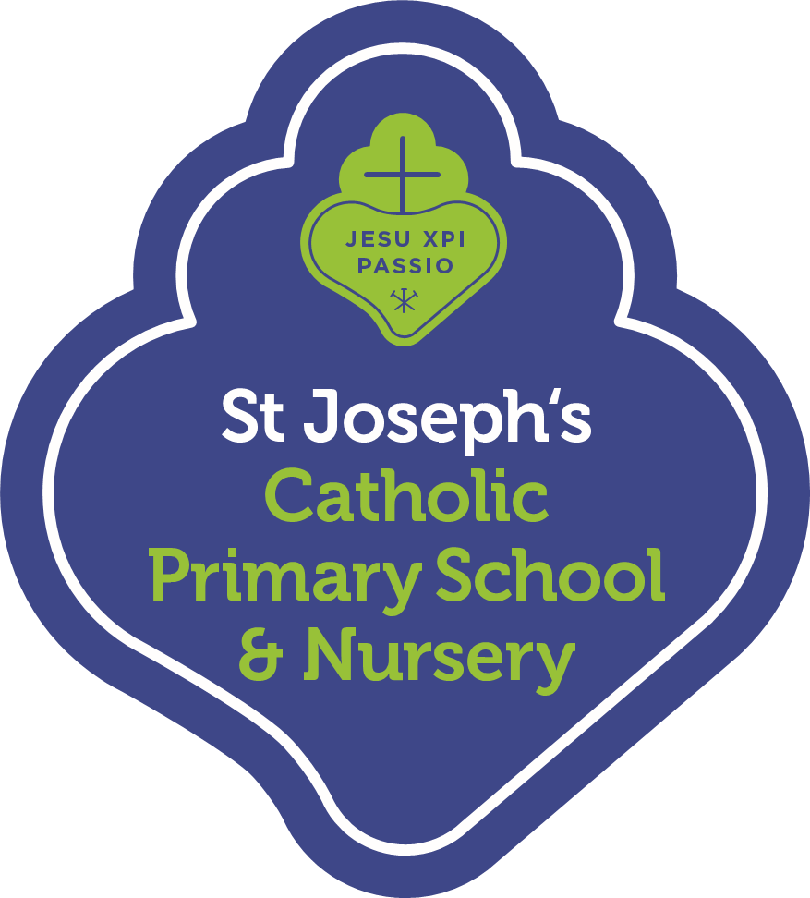
Spring Term 2022 Curriculum Summary for Parents
Over the next term, we will be working hard in the preparation for SATs to help children achieve their full potential. Once the exams are over we have the end of year production to look forward to, in addition to a wide range of transition activities as the children get ready for their move to secondary school. Here is a summary of our learning over the Summer term.
Religious Education
In RE, our topics this term include Pentecost and Reconciliation. Children will learn about The Feast of Pentecost as the celebration of both the gift of God’s Holy Spirit, and the trust God places in people to be witnesses in the world. Across the topic of Reconciliation, pupils will focus on helping and relating to others, including those who are sick and needing care.
English
In English, we are continuing to develop our VIPERS skills, reading a wide range of genres and exploring strategies to answer comprehension questions. We will be writing a number of creative pieces, including a suspense narrative and a piece of poetry, employing our learnt grammar and writing techniques to engage the reader.
Mathematics
In Maths we will begin the term by revising key concepts in preparation for the SATs. After the exams, we will continue our maths learning by carrying out a range of investigations and consolidating our learning in preparation for secondary school.
Science
In science, we will be learning about two forms of energy: light and electricity. The children will deepen their understanding of what they are, learn a range of related key vocabulary and continue to develop their working scientifically skills by carrying out fun investigations of various kinds.​
Computing
This term the children will extend their knowledge of coding using various coding languages such as HTML and Scratch. The children will continue to make links between computing and other subjects via blogging, handling data and video presentations.
History
In History, we will be learning about the Maya Civilisation. The children will explore the world of the Maya, and debate whether they should continue to be remembered today as a significant culture.
Geography
In Geography, children will explore the question ‘How will our world look in the future?’. They will consider the past, present and future of our local area. This will help pupils to see change as a positive thing, and feel optimistic about the changes that lie ahead going to secondary school.
Art & Design and Design Technology
During the first half-term, children will carry out a design and technology project using a wide range of materials, exploring the topic "People in Action". In summer 2, to link with our history topic of the ancient Mayans, the children will be creating their own Mayan masks.
Music
In music, children will build upon their knowledge of steady beat and rhythm, composing pieces together using percussion instruments.
PSHE/RSE
We will be exploring the topics Me, My Body, My Health and Life Cycles this term. Pupils will learn about the changes they will experience throughout puberty and reproduction.
Spanish
Children will further consolidate their learning in Spanish in preparation for languages at KS3.
PE
In PE children will be developing skills in football, gymnastics, outdoor athletics and tri-golf. A reminder, our P.E. days are on Wednesdays and Fridays.
We encourage you to engage with your child about their learning across the term in preparation for the SATs. Please continue to engage with the SAT Homework books and reading at home. Thank you for all your hard work and effort so far.
The Year 6 Team

