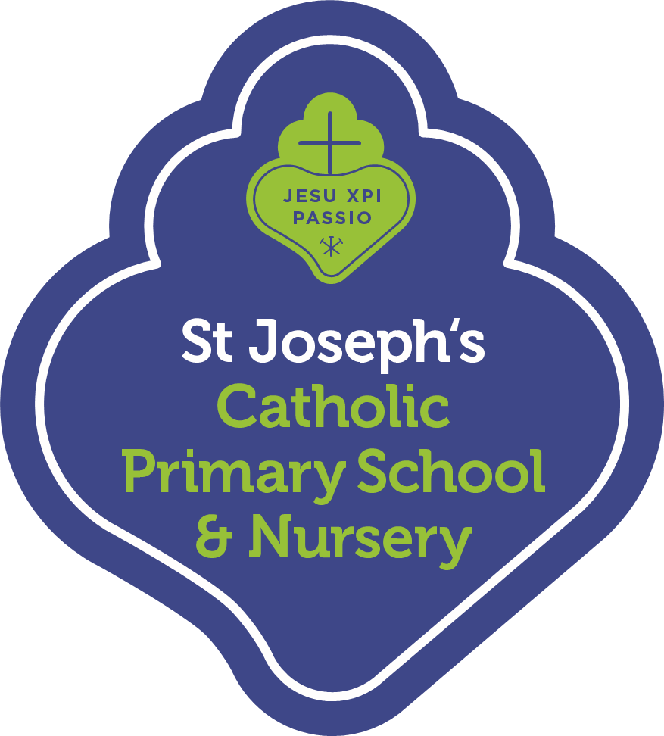
Year 5 Summer Term 2022 Curriculum Summary for Parents
Happy Easter to you all! Please find below a brief summary of the learning that will be taking place in Year 5 during the Summer term.
Religious Education
Year 5 will begin Summer term looking at the topic of ‘Transformation’, exploring the transformative power of the Holy Spirit. Then we will look at the topic of ‘Freedom and Responsibility’, and discussing how we can make good decisions using the free will given to us by God. Lastly, we will look at ‘Stewardship’ and what it means to be a steward for others.
English
In Speaking and Listening we will be further encouraging the children to explore tone and intonation to convey meaning; for example, presenting news reports. We will be reading ‘The Promise’ and ‘The Lost Book of Adventure’ compiled by Teddy Keen, as well as a class reader. In Writing children be writing both survival and character narratives. For non-fiction writing, the children will be exploring newspaper reports and survival guides.
Mathematics
In Maths, we will be covering five topics over the course of the term – Decimals, Properties of shape, Position and direction, Converting units and Measurement. It is essential that all children have quick recall of times tables facts to support their recall of division facts in number work.
Science
Our Science topics this term will be ‘Growing Up and Growing Old’ and ‘Circle of Life’. In the first topic, children look at and describe the changes as humans develop to old age. Pupils draw a timeline to indicate stages in the growth and development of humans and learn about the changes experienced in puberty. In the second topic children look at the life cycles of various species including mammals, amphibians, fish and birds. They also look at and describe the life process of reproduction in plants and animals.
Computing
In Computing the children will begin by participating in ‘Dragons Den’ themed activities and mapping historical parts of London. Then, they will revisit their Scratch explorations before finishing by creating a project on Ancient Greece.
History
In History the topic title will be ‘Journeys’ and the children will discuss the question - what makes people go on a journey? In this unit, the children will explore the question of why people go on a journey, and look at five very different types of journeys in depth. The journeys selected span from the Tudor period to those undertaken today by refugees.
Geography
In Geography children will be looking at the journey of clothes and will discuss the question - where does all our stuff come from? In this unit, the children will find out about the UK’s global trade links, investigating where everyday products come from and the journeys they take to our homes. This builds on work children may have done in KS1 looking at the geography of food. The children will also map the journeys taken by items, and research the pros and cons of buying local or imported goods.
Art & Design and Design Technology
This term children will be using mixed media to work on a variety of projects, including how to draw portraits. They will be specifically focussing on editing and improving their work to create a final piece.
Music
The children will be exploring rhythm and pulse through a variety of activities using percussive instruments.
PSHE
Children will be focussing on the importance in communication both in and out of school. We will be looking at the topics of ‘different influences’ and ‘borrowing and earning money’.
Spanish
Children will be continuing to focus on writing and saying short sentences inspired by a variety of topics.
PE
In PE, children will be developing skills in gymnastics, badminton, outdoor athletics and tri-golf. Children may wear their PE kit to and from school on their class PE days, and do not need to bring their school uniform to get changed into afterwards.
This is just a brief summary of what we will be learning about this term. Please talk to your child about their learning.

