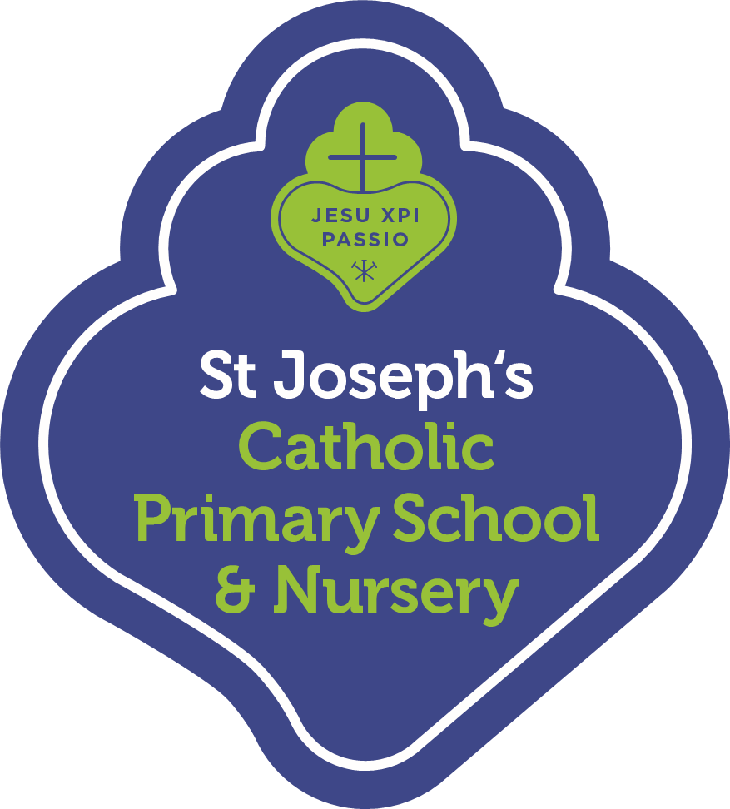
Summer Term 2022 Curriculum Summary for Parents
We are looking forward to another exciting term of working together with you to support your child’s learning. Please find below a brief outline of the learning that will take place this term.
Religious Education
In RE our topics this term will be Holidays and Holy Days and Being Sorry. We will also be learning about neighbours who share God’s world. Children will be learning about how God helps us to choose well. We will be also teaching the children about the birth of Krishna, a major Hindu deity.
English
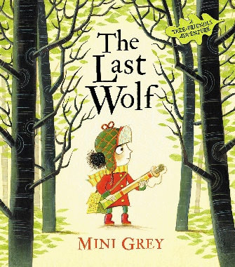
In Speaking and Listening children will be encouraged to articulate their ideas within full sentences and they will be encouraged to use past, present and future tenses correctly. In Reading we will continue to focus on learning the letter sounds and preparing for the Phonics Screening Check. In Writing children will be learning to create their sentences orally before scribing them. There will also be a focus on reading their own writing back to themselves and to their peers. In Spelling we will focus on spelling common exception words and the days of the week. In Handwriting we will continue to focus on forming our lowercase, capitals and digits correctly.
Mathematics
In Maths we will be consolidating and then building on the children’s understanding of place value within 100. The children will be introduced to the early stages of multiplication and division (using ‘groups of’ and ‘shared between’). We will begin to look at halves and quarters. As well as this, we will visit measurement of money and time towards the end of the year.
Science
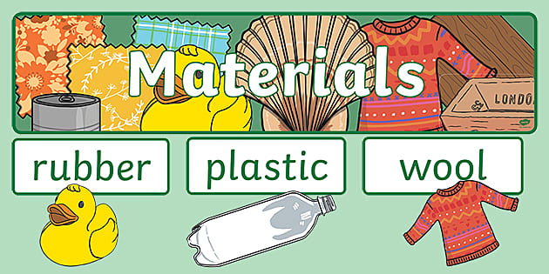
Our Science topics this term are ‘Celebrations’ and ‘Holidays’. Within our ‘Holiday’ topic, children will be learning to distinguish between an object and the material from which it is made identify. They will also identify variety of everyday materials including wood, plastic, glass, metal, water and rock. Within our ‘Celebrations’ topic the children be describing the simple physical properties of a variety of everyday materials.

Computing
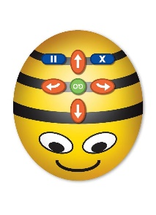
In Computing children will be learning to create their own maps using Beebots. They will also learn about coding through fun games and activities on Busy Things. The children will learn to quickly create, run and debug their own simple programs starring some exciting characters.
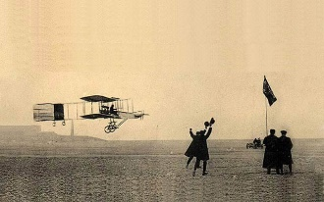
History
In History our topic is ‘Great Inventions: Transport.’ In particular, we will be considering how the first flight changed the world and why the Rainhill Trials were important.
Geography
In Geography our topic is ‘People and their Communities’. In this unit, the children take four different world journeys. Starting with their local area, they then look at coastal, rainforest, dry (desert) and world city locations. They will build on their understanding of the world’s seven continents and continue to learn to use maps, atlases and globes.
Art & Design and Design Technology
In Art we will continue to explore using a range of materials. We will develop our understanding of Artists by looking at the style of Lowry. We will also be making hand puppets and tie dye t-shirts!
Music
The children will be listening to and understanding live and recorded music. They will also learn to make and combine sounds musically.
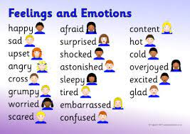
PSHE
Children will be developing their understanding of mental health and emotional wellbeing (feelings). The children will learn about managing their feelings, as well as change or loss and how this can feel. They will also learn where money comes from and about making careful choices with your money.
PE
In PE children will be developing skills in Athletics and Fundamentals. The children will develop a range of run, jump and throw techniques.
We encourage you to engage with your child about their learning across the term, particularly by reading regularly. Thank you for all your hard work and effort so far. We are having such a wonderful year and we cannot wait for all that is to come this term.
Miss Horne and Mr Murray

