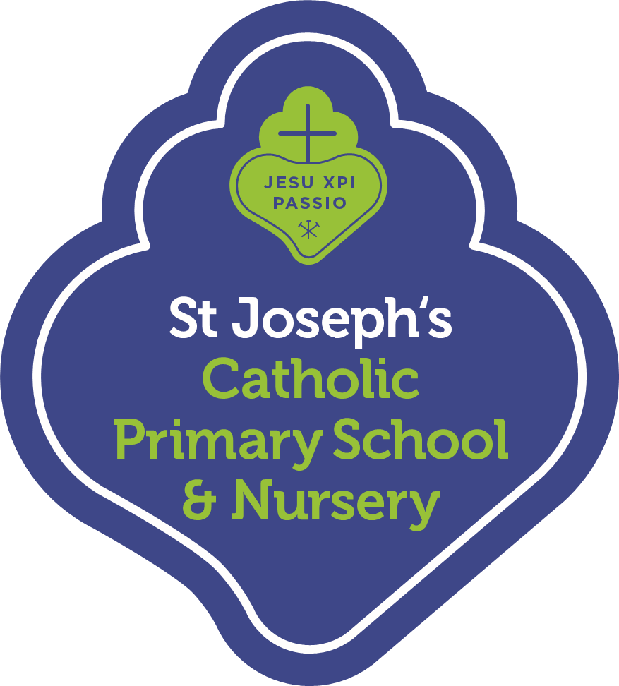
Reception Summer Term 2022 Curriculum Summary for Parents
We hope you all had a Happy Easter. Welcome back to our final term in Reception! The year has flown by. We are looking forward to many more exciting learning opportunities. We hope to see you at our Stay & Read (Monday) and Stay & Play (Friday) mornings. Thank you for your continued support.
Religious Education
In RE, our topics this term will be Good News, Friends and Our World. The children will be learning about what is celebrated at Pentecost, how we can be a good friend to others and the importance of looking after the world around us.
Personal, Social and Emotional Development
Children will be learning about how to keep themselves safe and healthy. We will be exploring healthy choices for our body and mind through circle times and practical activities. We will be working with the children to support their transition into Year 1.
Communication and Language
Children will continue to learn new vocabulary and will be encouraged to use and apply these words with confidence in their speaking and writing. They will be learning to extend the detail in their sentences and storytelling. We will be exploring poems, rhymes and songs as well as our key texts.
Physical Development
Children will be continuing to develop their letter formation so that their writing can be read by others and will be adding more detail to their drawings. They will do this by strengthening their fine motor skills in a range of activities. In PE, the children will be learning a range of games and ball skills. They will be developing their balance and agility as well as their coordination and cooperation skills.
Literacy
Our focus in Phonics will be consolidating our learning in Reception through Phase 4. Children will be reading books with increasing confidence and fluency. The children will be able to demonstrate an understanding of what they have read and what has been read to them. They will be writing for a range of purposes (story writing, non-fiction writing and innovating familiar stories). The children’s writing will include capital letters, full stops and finger spaces.
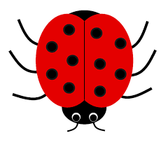
Mathematics
In Maths, Reception will be exploring and building numbers beyond 10. They will be developing their understanding and confidence in adding and taking away. The children will be learning about doubling, sharing and odd and even numbers. They will have the opportunity to explore patterns in numbers, shapes and colours.
Understanding the World
Our Summer term topics will be: Food, Glorious, Food and Imagine. The children will be exploring where food comes from, how fruit and vegetables grow and making their own recipes. They will be learning about different countries and cultures. They will develop their understanding of change over time, the natural world and take part in investigations.
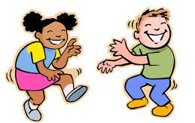
Expressive Arts and Design
Children will be developing their imagination through hearing and retelling fantasy and traditional stories. They will be learning traditional songs from around the world and have the opportunity to perform songs, dances and music. Reception will be exploring colour mixing and joining a range of materials to create their own models.
This is a brief summary of what the children will be learning this term. Please read with your child daily and leave a comment in their purple reading record. Reading books and records must be in school every day. We are happy to welcome parents/carers into school if you would like to talk to your child’s class about our new topics and learning.

