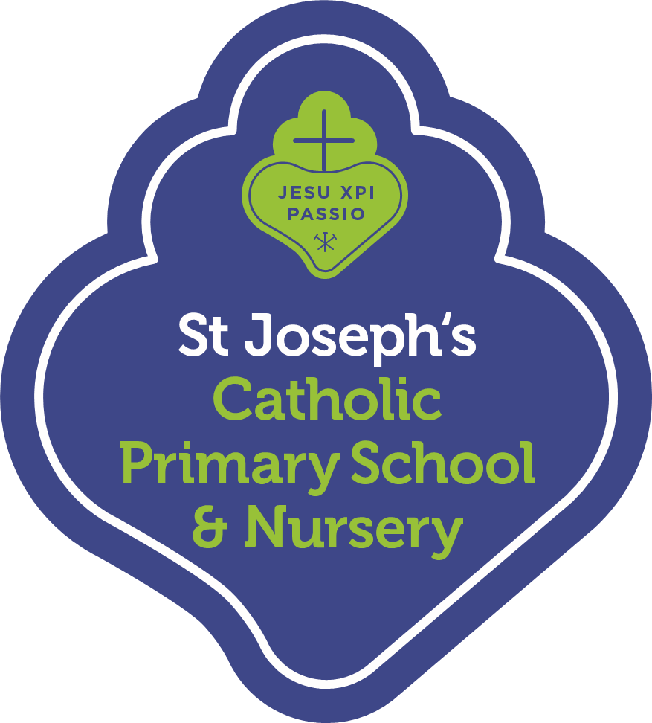
Summer Term 2022 Nursery Curriculum Summary for Parents

We hope you had a wonderful Easter holiday and we welcome you back to St Joseph’s. We are looking forward to another successful term working with parents to support each child’s learning. We hope to see you at our Stay and Read (Monday) and Stay and Play (Friday) mornings. Thank you for your continued support.

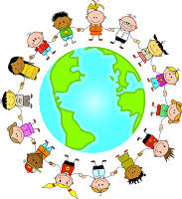
Religious Education
In RE our topics this term will be Good news, Friends and Our World. Children will be learning about Pentecost and celebrating their own good news. They will then focus on friendships, and how we can look after God’s wonderful world.

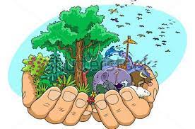
Personal, Social and Emotional Development
Children will be learning the importance of looking after ourselves, our world and its living things. They will be encouraged to take responsibility for their environment, and select their own activities and resources independently in preparation for their transition into Reception.

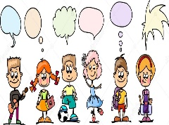
Communication and Language
Children will be learning to use language effectively to widen contacts, share feelings and take turns. They will be encouraged to explain their own thinking and ideas. They will be learning to listen without visual support, to ask simple questions and to follow more complex instructions.

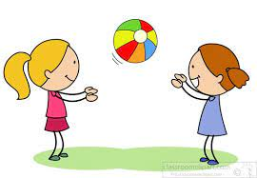
Physical Development
Children will be extending their fine motor skills by accessing a wider variety of tools and resources. They will explore a range of joining techniques and develop more control and complexity in their mark-making activities. They will be focussing on games and ball skills in their twice-weekly P.E sessions, as well as developing strength and agility outside with their continuous outdoor provision.

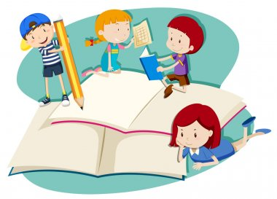
Literacy
In Phonics we will be focussing on Phase 1. We will be working on alliteration, then segmenting and blending short words. In Literacy children will be learning to identify sounds and will begin to write letters such as those in their name. They will learn to identify signs and print in the environment, and understand the direction that text is read. They will be encouraged to use their print and letter knowledge in their own early writing activities.

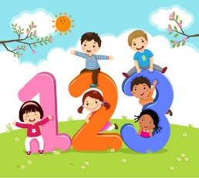
Mathematics
In Maths we will be learning fast recognition of a small number of objects, and to represent them with numerals, fingers and marks. We will strengthen our counting skills and begin to learn about taking away. We will develop informal and mathematical language to describe shape and describe sequences of events in order.

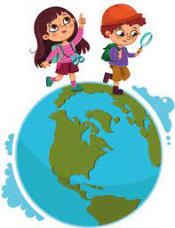
Understanding the World
Children will be learning about different places, and will be encouraged to talk positively about the similarities and differences between people and what is special in the world. They will learn to talk about materials, natural forces and changes using simple scientific language.

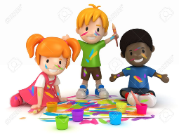
Expressive Arts and Design
Children will observe the work of artists and will be learning to draw identifiable features. They will explore and describe texture and develop their own ideas when selecting materials to express themselves. They will also work on performing a short repertoire of familiar songs.

This is a brief summary of what the children will be learning this term. Please continue to talk with your child about their learning at school and to read with them daily. We are happy to welcome parents/carers into school if you would like to talk to your child’s class about our new topics and learning. This be arranged with the class teacher.

