Year 2 Parent Summary: Summer Term

Welcome back to school! We hope that you enjoyed the Easter holidays and are rested, relaxed and ready for this exciting new term! Below is a brief summary of some of the areas will be focusing on during the Summer Term.

English
In English, the children will be continuing to develop their reading fluency through reading a range of comprehension texts. They will also be developing key reading skills which include, retrieving, inference, summarising and predicting.

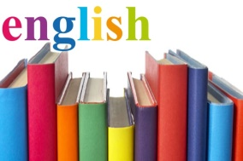
In English Writing, children will be developing their writing stamina and will have lots of opportunities to apply different SPaG (spelling, punctuation and grammar) features to their writing. They will be doing this whilst studying recounts, formal letters and instructional texts. There will also be a focus on children independently re-reading, editing and improving their writing.

Maths
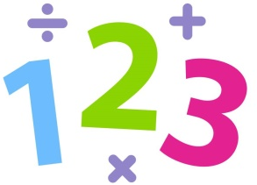
In Maths, we will be learning about what fractions are and how to write different fractions. Children will then be finding different fractions of shapes and amounts. During the Summer Term, we will also be learning about comparing intervals of time. Children will be using the vocabulary quarter past, quarter to and half past and will be drawing hands on a clock face to show these times.

Science
In Science, the children will be learning about a topic called Living Things and their Habitats. Children will be taught to identify things that are living, things that are dead and things that have never lived. They will also be learning that most living things live in habitats that are suited to them. Children will be able to identify different animals and habitats that are suitable for them.

Computing
In Computing, children will be using Bee Bots to create simple programmes. They will also be using Scratch software to create algorithms.

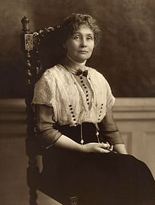
History
In History, the children will be learning about significant women from the past. During this Topic, they will learn about their lives and achievements and how they have impacted the world we live in today.

Geography
In Geography, we will be making links with our History learning and will be learning about significant women from the local area and how they have impacted the world around us.

DT
In Design and Technology, the children will be designing and making their own lanterns like the one Florence Nightingale famously used. They will evaluate their ideas and designs afterwards to develop critical understanding of the impact and use of their creation.

Art
We will be studying different pieces of artwork linked to our topic Wonder Women such as the portraits of Elizabeth I and discussing the symbolism of these paintings. We will look at the different techniques that were used to create the artwork and will be recreating our own pieces of art based on symbolic portraits.

Music
In Music, the children will be exploring the concept of beat through their singing lessons. They will continue to have the opportunity to sing solo, in partner work and with whole class singing, aiding the development of their performance skills and music appreciation.

PE
In PE, the children will be developing their movement and agility skills. Children will then be applying these skills when completing Athletics activities, such as running, hopping, skipping and jumping.

PSHE
In PSHE, we will be learning about how we can keep safe in the home (including fire safety), outside and when crossing the road. They will discuss the importance of keeping safe and the right actions to take to ensure they maintain this safety.

Please remember this is only a brief outline of what your child will be learning about this term. We look forward to a fantastic term with your child.

Many thanks,
Miss McCaughey and Miss Clarke

