Year 1 Parent Summary Summer Term 2021
Welcome back everyone! Below is a brief summary of some of the areas the children will be studying during the summer term.
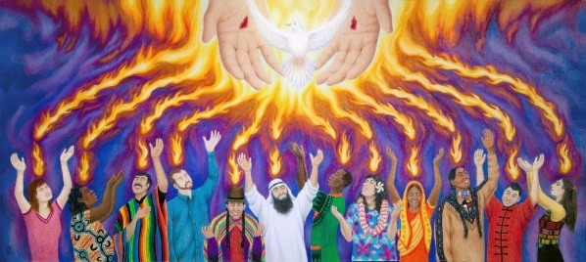
Religious Education
In Religious Education the children will learn about the events in the 40 days after Easter from the Resurrection of Jesus Christ to Pentecost. The children will also begin to learn about Reconciliation.

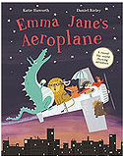
English
The children will listen to and write about both fiction and non-fiction texts and we will also explore poetry once again. Some of the texts we will cover include; ‘Emma Jane’s Aeroplane’, ‘Journey’ and Amelia Earhart (Little People, Big Dreams). Children will practice writing different text types including; recounts, information and persuasive. Children will continue to take part in daily phonics activities and regular handwriting practice. They will continue to develop their speaking and listening skills using drama and role play.

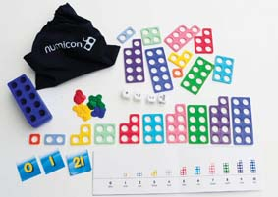
Mathematics
This term in Maths the children will continue to learn about multiplication and division, relating it to real life situations. They will be developing problem solving skills during Maths investigations. They will also begin exploring simple fractions including halves and quarters. The children will learn about measurement of time and money using correct mathematical vocabulary to explain concepts. They will also develop positional language learning about turns and directions. We will continue to use practical resources and electronic activities such as Doodle Maths to support and engage pupils in the joy of Mathematics.
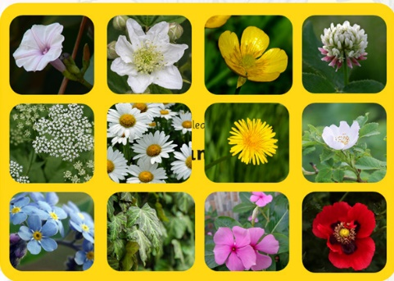
Science
The Science topic this term is ‘Plants.’ Children will learn to identify and name a variety of common wild and garden plants, including deciduous and evergreen trees. They will also begin to identify and describe the basic structure of a variety of common flowering plants, including trees. Children will explore how plants can be adapted to their environment.

Computing
In Computing the children will use technology purposefully to create, organise, store, manipulate and retrieve digital content. They will do this predominantly through the use of Tapestry. Later on in the term they will also continue to develop their programming skills.

. 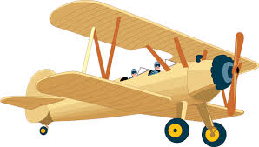
History
The theme for the second half term is ‘Flight’. The children will learn about the history of flight and some key individuals and their achievements including Amelia Earhart and the Wright Brothers
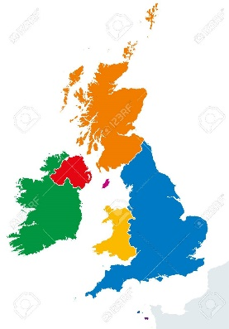
Geography
This term we will be studying the ‘British Isles’. Pupils will be able to identify the five countries that make up the British Isles; England, Ireland, Northern Ireland, Scotland and Wales. They will learn about human and physical features of each country including the names of capital cities and key rivers.
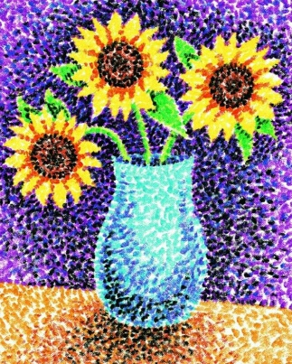
Art & Design
In Art and Design the children will continue to use pencils, paints and materials to create pictures that reflect the learning across the curriculum including aircrafts , other world creatures, plants and flowers.

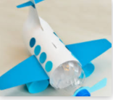
Design and Technology
Children will design, make and evaluate products linked to our learning across the curriculum such as airplanes and vases.

Music
In Music the children will continue to take part in weekly lessons using rhythm and beat. They will explore different instruments and different tempos to then create their own compositions.
PSHE
In PHSE the children will participate in circle time activities and games focusing on the topics of ‘Mental Health and Emotional Wellbeing’. In the second half term we will focus on careers, financial capability and economic wellbeing.

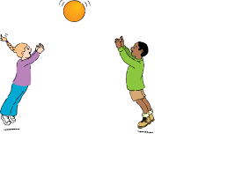
PE
In PE our focus will be on catching and throwing. These are the key parts of team and individual invasion, territory and striking and fielding games.

Please remember that this is only a brief outline of what your child will be learning about during this term.

Miss McCarron and Miss Dwyer

