Year 4 Spring Term Parent Summary

Welcome back for the Spring Term 2021! We hope you have all had a wonderful, safe Christmas break. As you will see below, the children will be introduced to lots of exciting new topics this term and will also build on their previous learning in many areas. We are really looking forward to getting started!

English
In English this term, there will be a continued focus on grammar and punctuation and spelling and the children’s correct use within independent writing. We will be reading a range of genres including information leaflets and narratives, within which we will be incorporating all reading skills e.g. inference and retrieval. Themes within writing will include work linked to the World Kitchen topic and poetry.
Maths
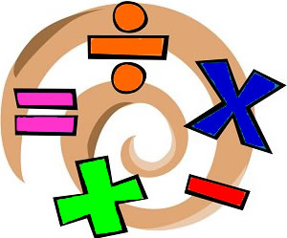
In Maths this term, the children will be completing work on ‘Fractions’. The children will learn how to find fractions of amounts, what equivalent fractions are and how to convert fractions into decimals. The children will also work on securing their knowledge of the four number operations and written methods of calculation; such as column addition and subtraction, several methods for multiplication and bus stop method for division.
The children will then move onto decimals, looking at tenths and hundredths and the relationship with fractions. There will still be a focus on multiplication tables in order to encourage instant recall through our times table challenges. We will be using investigations and problem-solving activities to deepen the children’s understanding of the content.


Science
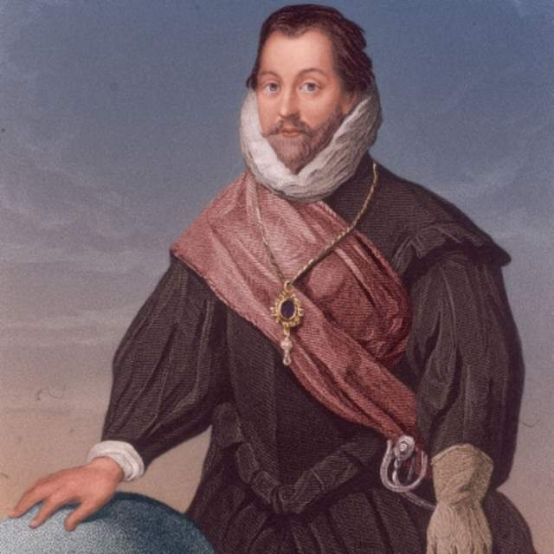
In Science, the children will be learning about States of Matter. The children will investigate the particle formation of solids, liquids and gases, as well as the process of heating and cooling. Deeper into the topic, the children will explore the water cycle.

Geography and History
This term our topic is World Kitchen. The children will use an atlas to locate capital cities and countries around the world. They will learn about where different foods come from, including investigating where ingredients on a pizza originated from and the distance between the UK and their origin. They will learn about Fair Trade through chocolate and how the food cuisine in Britain has changed over the last 100 years.

Art and Design

In Art, the children will look at shading techniques used by renaissance artists, as well as water colour painting.

Design and Technology

This will include designing and cooking a variety of world foods, whilst looking at the origins of each ingredient, linking to the World Kitchen topic.


Computing
In Computing, the children will begin by looking at E-Safety, producing work to show the importance of staying safe online including when blogging using J2e.com. The children will then focus on using code to write simple games. The children will continue to use a range of apps such as book creator and pic collage to support their learning.

Physical Education

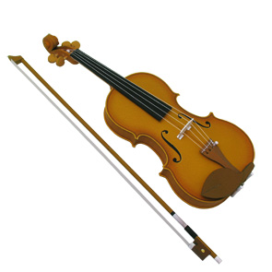
Children will need a PE kit each week for all lessons. In PE, the children will be focussing on the fundamental movement skills ‘object control’ and ‘stability.’ Such skills will be incorporated into a range of different games.

Music
In Music, the children will continue learning how to read music and improve their skills playing the violin.

PSHE
In PSHE this term, the children will be looking at how and why Britain is a democratic society and how laws are made. Further into the term, the children will be moving onto what contributes to people’s food choices and the importance of getting enough sleep.

