Year 2 Parent Summary: Spring Term

Welcome back to school! We hope you have enjoyed the Christmas holidays and are rested, relaxed and ready for this exciting new term! Below is a brief summary of some of the areas the children will be focusing on during the Spring Term.

English
In English, the children will continue to develop their reading fluency and comprehension skills. Reading with adults at home as well as at school will maximise progress and confidence.

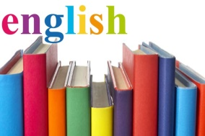
In English Writing, we will be using different texts linked to our topic Indian Spice as a stimulus. The children will be writing diary entries and letters in role. Different SPAG (Spelling, Punctuation and Grammar) focuses will be taught through discrete lessons and the children will then be challenged to include these different focuses in their independent writing.

Maths
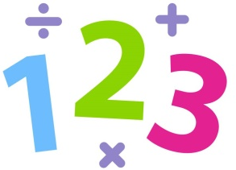
In Maths, the children will continue to develop their understanding of number through exploring multiplication and division. They will have opportunities to apply their learning to real life contexts and learn about how to use these skills to solve problems.
They will use practical resources to support them when learning about new topics such as fractions and shape.

Science
In Science, the children will be learning about a topic called Animals including Humans. They will look at the different stages of the life cycle observing changes that occur in humans and different animals as they grow. This unit will also focus on the different needs that humans and animals have and how exercise, diet and hygiene impacts on their lives.

Computing
In Computing, children will be learning how to programme physical devices. They will then be applying these skills in order to make a device travel in different directions.

History
The children will be learning about significant figures in British history, focusing specifically on Amelia Earhart. They will learn about how Amelia Earhart influenced Britain and what we can learn from her influence today.

Geography
In Geography, the children will learn about the location of India, which continent it is a part of and the locality of its main cities. They will also begin to study the physical and human geographical features of the cities and compare a city in India with a city in London. The children will use atlases, globes and maps in their learning to help develop their geographical skills.

DT
In Design and Technology, the children will be designing and creating a traditional Indian Dhol drum. The children will create this from a range of materials and will evaluate their ideas and designs afterwards to develop critical understanding of the impact and use of their creation.

Art
The children will be studying different pieces of artwork created by Indian artists. They will look at the different techniques and mediums that were used to create the pieces and will be recreating their own pieces of artwork, including a traditional Indian Rangoli pattern.

Music
In Music, the children will be exploring the concept of pitch and rhythm through their singing lessons. They will have the opportunity to sing solo, in partner work and with whole class singing, aiding the development of their performance skills and music appreciation.

PE
In PE, the children will be developing their movement skills. Children will be able to use these skills to support them when participating in individual and team-based games. They will also be learning a traditional dance of India, the Bhangra dance, to connect to our topic.

PSHE
In PSHE, the children will discuss the meaning of community and what different communities they belong to. They will also consider how their community supports them and how they can contribute to their community.

Please remember this is only a brief outline of what your child will be learning about this term. We look forward to a fantastic year with your child.
Many thanks,
Miss McCaughey and Miss Clarke

