**Year 1 Parent Summary Spring Term 2021**

**Happy New Year to all parents and carers! We would like to welcome you to our Spring term and tell you about all the exciting things the children will be learning about!**

**English C:\Users\afitzgerald.STJOSEPHSCC4\AppData\Local\Microsoft\Windows\Temporary Internet Files\Content.IE5\U9FEIO6T\MC900384132[1].wmf**

**The children will listen to and write about both fiction and non-fiction texts and we will also explore poetry once again. Some of the texts we will cover include; ‘Beegu’ and ‘Man on the Moon’. Children will practice writing different text types including; recounts, information and persuasive. Children will continue to take part in daily phonics activities and regular handwriting practice. They will continue to develop their speaking and listening skills using drama and role play.**

**MathematicsC:\Users\afitzgerald.STJOSEPHSCC4\AppData\Local\Microsoft\Windows\Temporary Internet Files\Content.IE5\UR33T7ED\MC900130271[1].wmf**

**This term in Maths the children will continue to learn about addition and subtraction and will begin to relate it to real life situations. They will be developing problem solving skills during Maths investigations. The children will explore patterns, volume, length and weight and use the appropriate vocabulary to describe them. The children will also continue to use a number line and a 100 square to solve calculations. We will continue to use Doodle Maths and Numbots to support and engage pupils in the joy of Mathematics.**

**Science**  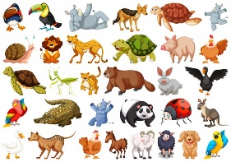

**The Science topics this term are ‘Animals including humans’ and ‘Seasonal Changes’. We will learn about animal groups and make comparisons between the bodies of humans and other animals. We will also look at the differences between the four seasons and identify and recognise changes for example, climate.**

**Computing** [](http://www.google.co.uk/imgres?q=computer&safe=active&biw=1280&bih=929&tbm=isch&tbnid=33T7LySP4YbgUM:&imgrefurl=http://www.landportcommunity.org.uk/groups/computer.php&docid=7EIaCn4StNk9gM&imgurl=http://www.landportcommunity.org.uk/images/computer2.gif&w=2048&h=1725&ei=-5vmUYicB8jLhAfhpYHYDQ&zoom=1&ved=1t:3588,r:7,s:0,i:101&iact=rc&page=1&tbnh=186&tbnw=221&start=0&ndsp=20&tx=108&ty=89)

**In computing this term the children will look at creating their own sprites (gaming characters). In addition to this they will continue to develop their coding skills in using and understanding algorithms using a programme called Scratch. The children will also develop their digital literacy skills by exploring online neighbourhoods (games), the importance of switching off devices and how to use the internet safely.**

**Art & Design Technology**  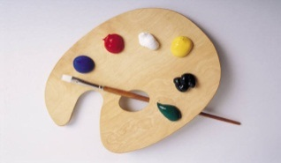

**In Art and Design the children will continue to use pencils, paints and materials to create pictures that reflect the learning across the curriculum including space craft, animals and landscapes.**

**In Design and Technology Children will design, make and evaluate products linked to our learning across the curriculum such as a spacecraft and igloo’s.**

**Geography** 

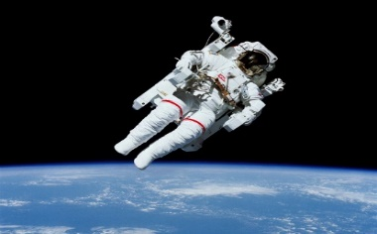**The theme for the first half term is ‘Poles Apart.’ Within this topic the children will learn about maps, atlases and globes to locate different continents, including arctic regions. Children will also be learning about the geography of the British Isles including its key rivers. In addition to this they will be able to locate the equator and explain how it affects climate. The children will use a range of different sources of research e.g. books, pictures, photographs and the internet.**

**History**

**In History our theme is ‘Space Flight’. Pupils will learn about the history of space flight and learn to put events in chronological order. They will also learn about the lives and achievements of some significant individuals from this field, such as the British astronaut Tim Peake**

**Music **

**In Music the children will continue to take part in their weekly singing lessons. They will explore pulse, rhythm and pitch during their music lessons. We will also be working from the Charanga Scheme.**

**PSHE**

**In PHSE the children will participate in circle time activities and games focusing on the topics of ‘’Myself and Other’ and ‘Feelings?’ Within these themes the children will learn about** what makes themselves and others special and about different types of feelings and how to manage them.

**Please remember that this is only a brief outline of what your child will be learning about during this term.**