December 2020
St.Joseph’s History & Geography Newsletter
Welcome to our first newsletter celebrating all of the wonderful History and Geography work that has taken place this term across the school.
From Remembrance Day to the Stone Age, we have explored a range of historical events. From our own homes, local area and school to Roman journeys, we have discovered places near and far. Here are some photos of what we have been up to!
Reception
Nursery
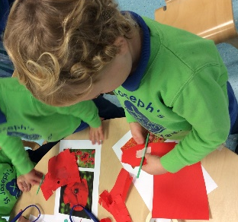
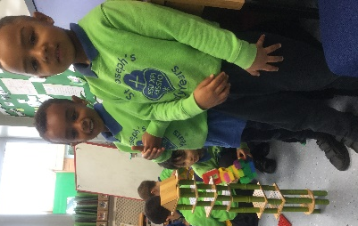

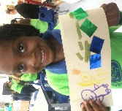
Reception talked about important events in the past and what they would like to be in the future. We talked about our homes and built them using construction. We also mapped out different geographical features using the Bear hunt story!

Nursery made poppies for Remembrance Day and painted fireworks to celebrate Bonfire night.

Year 1
This half term in History, Year One has been looking at the ‘Toys of the Past’. The children shared what their favourite toys were, and why they were special to them. Following that, they thought about what toys in the past may have looked like. Students had lots of fun playing with the old Victorian toys!
In Geography, we looked at the Geography of our school through our topic Superheroes. We made maps of our school using different resources, found out about our local area and our School’s location, as well as mapping our school buildings and outdoor areas!
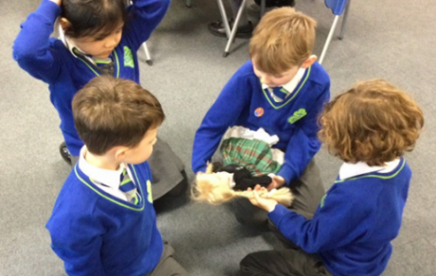
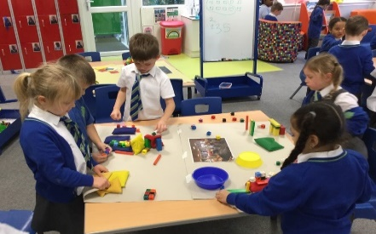
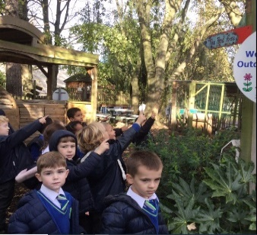

Year 2
In Year 2 we have been learning all about The Great Fire of London! We participated in a fantastic drama workshop where we learnt about the different characters involved in the event, such as Samuel Pepys and King Charles 11. We focused on our chronological skills when we collaborated in small groups to sequence the events of the fire! Our learning was brought to life with the use of the VR headsets.
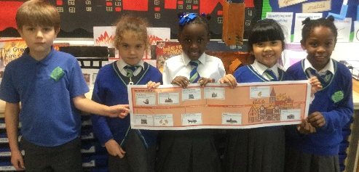

Year 3
Year 3 have been learning all about the Stone-Age this term. The children had the opportunity to immerse themselves in the Stone Age way of life by acting out different cultural tendencies, hunting techniques and the development of our first tools! The children loved learning about our early ancestors. Year 3 are now moving on to the growth of transport for Spring term.
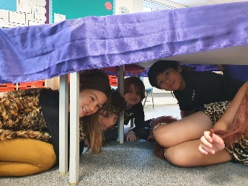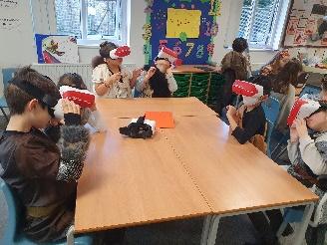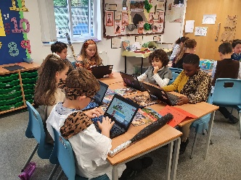
Year 4
Year 4 took a trip back in time to the ruins of Ancient Rome. We have been busy exploring the detailed livings of the in the Roman Empire, through the use of Virtual Reality, Art, Music, Literacy and Numeracy. We enjoyed tracing the journey which the Romans took in their conquers during our Geography lessons. We look forward to immersing ourselves in our next exciting topic- ‘Kitchen Around the World’.
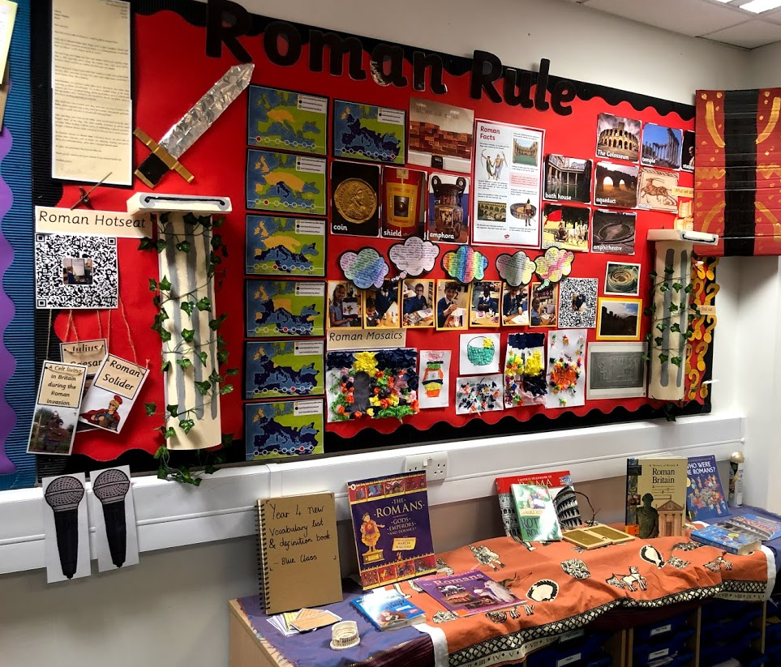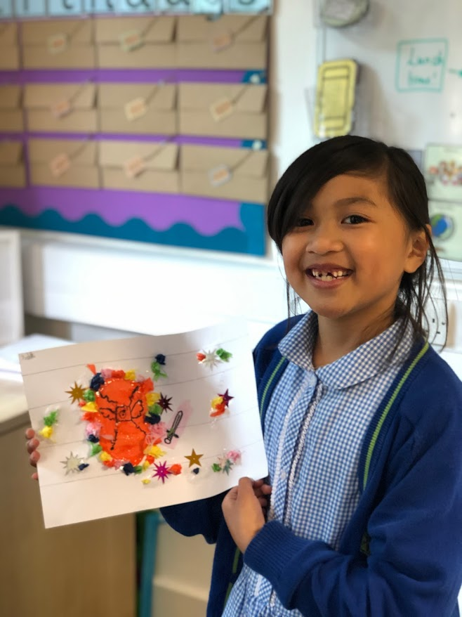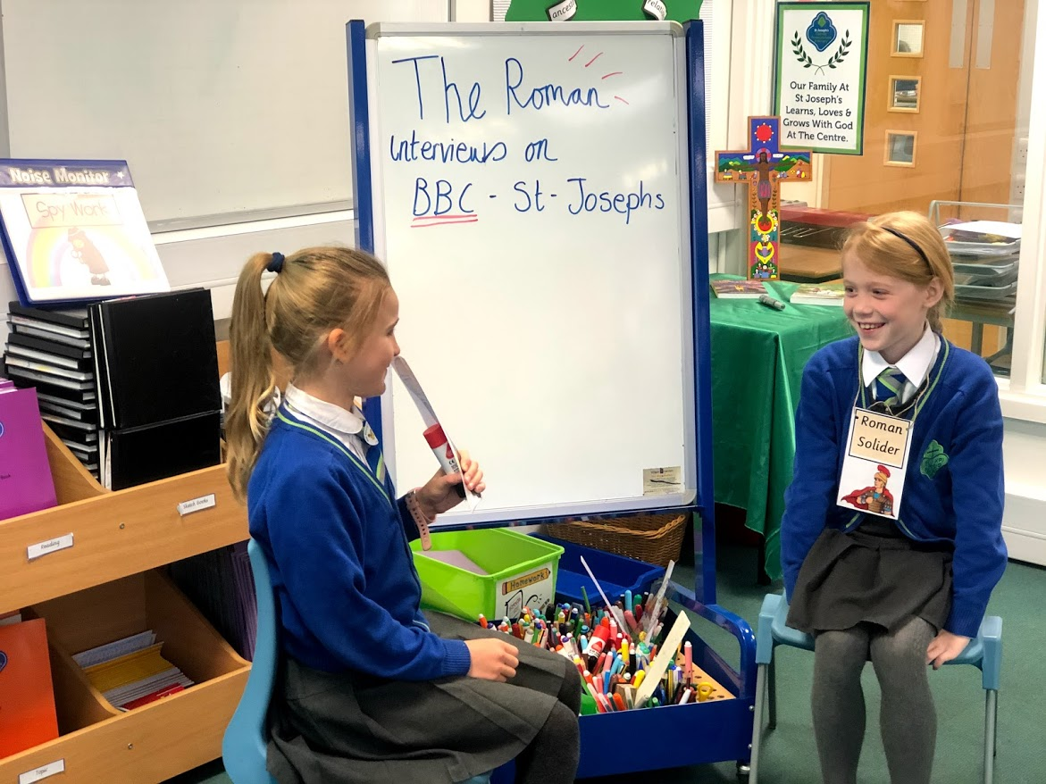
Year 5
Year 5 were studying the Anglo Saxons. They enjoyed an outdoor exploration activity finding out information about Anglo Saxon Kings. They worked in groups to decipher information about the different Kings and which King would have ruled during which period.
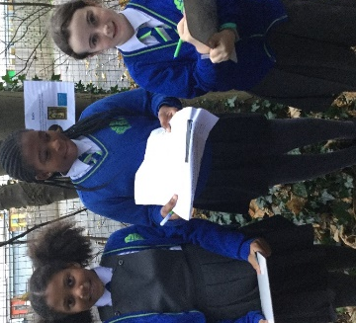
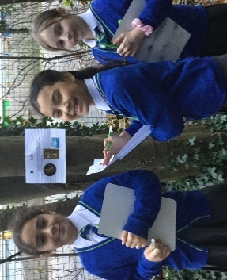

Year 6
The children continued their learning from the Anglo Saxons in Year 5, to the invasion of the Vikings and their settlement in Britain. We looked at key events creating living timelines, where we debated the impact of different events. We also imagined the battle of Lindisfarne from different perspectives, and wrote newspaper reports on this significant historical battle. We have been very lucky to work alongside Sophia our environmental tutor this term in two Viking workshops, one where we looked at how Vikings built their homes and another where we baked our own Viking bread in the cob oven. We have very much enjoyed delving into the world of the Vikings in Britain!
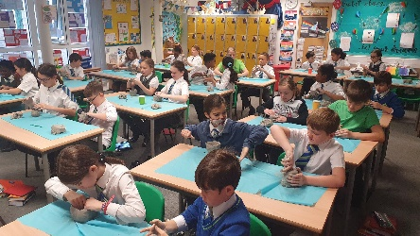
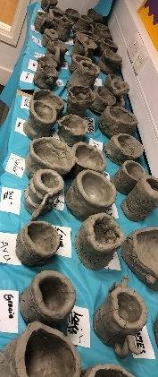

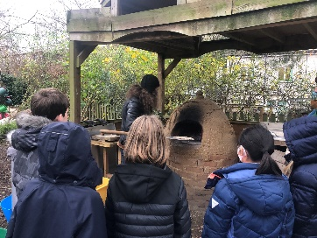

Thank you for taking the time to read our History and Geography newsletter. We look forward to updating you with some more learning in the Spring term!

