Year 4 Parent Summary Autumn Term
Welcome back for the Autumn Term 2020! What an exciting term we have lined up in our Year 4 curriculum! As you will see below, the children will be introduced to lots of new topics and also build on their previous learning. We can't wait to get started and are really looking forward to getting to know all of the new Year 4 children.

In Maths, the children will start by learning about place value. They will then practise the four number operations (addition, subtraction, multiplication and division) working with numbers up to 10,000. The children should become confident with the column method for addition and subtraction, the bus stop method for division and the grid method for multiplication. The children will be spending lots of time focusing on their reasoning when problem solving. They will then learn about measurement which includes perimeter and area of 2D shapes. The children will measure using standard units and recognise the relationship between these units. There will also be weekly Mental Maths practice.
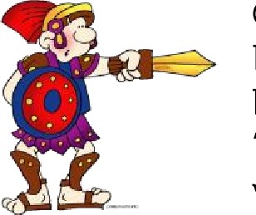
Our History and Geography lessons this term will focus on ‘Romans’. The children will learn about Roman Gladiators, Emperors and the Roman legacy, with a focus on the role of the Roman Soldier and Roman battle formations. The children will also discover how and why the Roman rule ended.
In English, the children will develop writing through a range of genres including poetry, persuasive writing and newspaper reports. Punctuation, grammar and spelling will continue to be developed, as will reading through daily lessons. The children will develop their ability to read in silence, choose suitable reading material confidently and read aloud with expression. Much of their writing will be linked with their History and Geography work on the Romans.
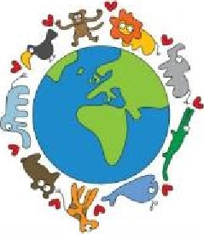
In Science, the children will investigate the habitats of living organisms and the differences between groups of plants and animals. We will then classify them into broad groups based on their chrematistics, and study how living things adapt to their habitats.
In Computing, the children will be learning how to use code to write simple games as well as using programs to create a branching database to organise plants and animals. The children will use their researching skills to find out about the Romans, and create their own blogs.
In PE, we will focus on locomotor skills and stability. Please ensure your child has the correct school PE kit for every lesson.
In PSHE this term, the children will be learning about democracy. They will find out how Britain works as a democratic society and how laws are made. We will also be completing a range of mindfulness activities.
In Music, the children will begin learning how to read music whilst playing the violin.
In Art and Design, the children will be planning, designing and creating Roman swords and shields.
Please remember that this is just a brief outline of this term's plans and does not include everything the children will be doing.

