Year 2 Parent Summary: Autumn Term

Welcome to Year 2! We hope that you have enjoyed the holidays and all the children are rested, relaxed and ready for this exciting term! Below is a brief summary of some of the areas the children will be focusing on during the Autumn Term.

English
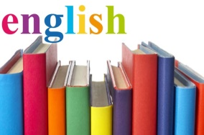
In English, the children will read a range of texts both fiction and non-fiction. As the children move through Year 2, the intention is that almost all children will secure the basic skill of decoding so that they can become fluent readers. Once children are able to ‘decode’ the writing, they can then start to make sense of the words and sentences in context. Once the children are more confident, the emphasis begins to shift to developing their comprehension skills.
English work will focus on the events of the Great Fire of London. They will learn to write using a range of text structures including diaries and reports. They will also explore a range of poetry, discussing the meaning of specific poems and creating their own. The children will be expected to use full stops and capital letters. In handwriting, they will practice correct letter formation each week.

Maths
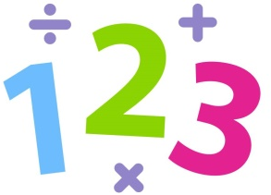
In Maths, the children will develop their understanding of number and place value using the four operations. They will use practical resources to learn about addition and subtraction and they will begin to learn their number bonds for numbers up to 20. In addition to this, the children will explore number and shape patterns and investigate number and word problems.

Science
In Science, the children will be learning about Materials and their everyday uses. They will work with a variety of materials and investigate how materials can be changed. They will identify and compare the suitability of a variety of everyday materials, including wood, metal, plastic, glass, brick, rock, paper and cardboard for particular uses. As well as this, your child will find out how the shapes of solid objects made from some materials can be changed by squashing, bending, twisting and stretching and applying forces.

Computing
In Computing, the children will be learning about e-safety. They will also continue to develop their keyboard skills. The children will continue to use different programs to develop their coding skills and learn how to ‘de-bug’ a game they have made.

History
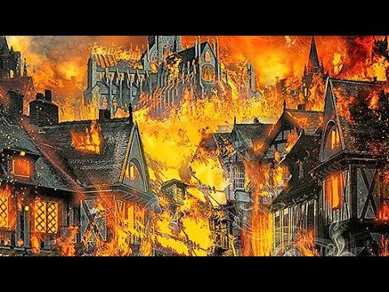
In History, the children will learn about The Great Fire of London. They will investigate the causes of the fire and why it spread so quickly. In addition to this, they will compare differences in London, before and after the Great Fire. They will also use a variety of sources to ask and answer questions about the Great Fire of London.

Geography
In Geography, the children will learn about the geographical features of London and where it is. They will focus on naming the oceans and continents of the world and the countries of the UK. We will also further develop map reading skills and link these to Maths.

DT
In DT the children will design and make a Tudor home based on their knowledge of Great Fire of London. You will be asked to send in some boxes and other items to support this at a later date.

Art
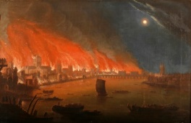
We will be studying different pieces of artwork from the Great Fire and will be learning about how Art has helped to teach us about what was life was like at that time. The children will have the opportunity to practise different techniques when recreating work in the style of the pieces we study.

Music
In Music, the children will be exploring different sounds and instruments. I think you need to be a bit more specific here. A little bit more detail.

PE
In PE, they will participate in games to improve coordination and control of their bodies. The children will also develop their gymnastics skills using larger and smaller apparatus.

PSHE
In PSHE, the children will discuss friendship and respect for each other. They will continue to learn about the world around them. They will also learn about keeping safe online and offline, the importance of keeping personal information secure and how to be safe on the computer.
Please remember this is only a brief outline of what your child will be learning about this term. We look forward to a fantastic year with your child.

Many thanks,
Miss McCaughey and Miss Clarke.

