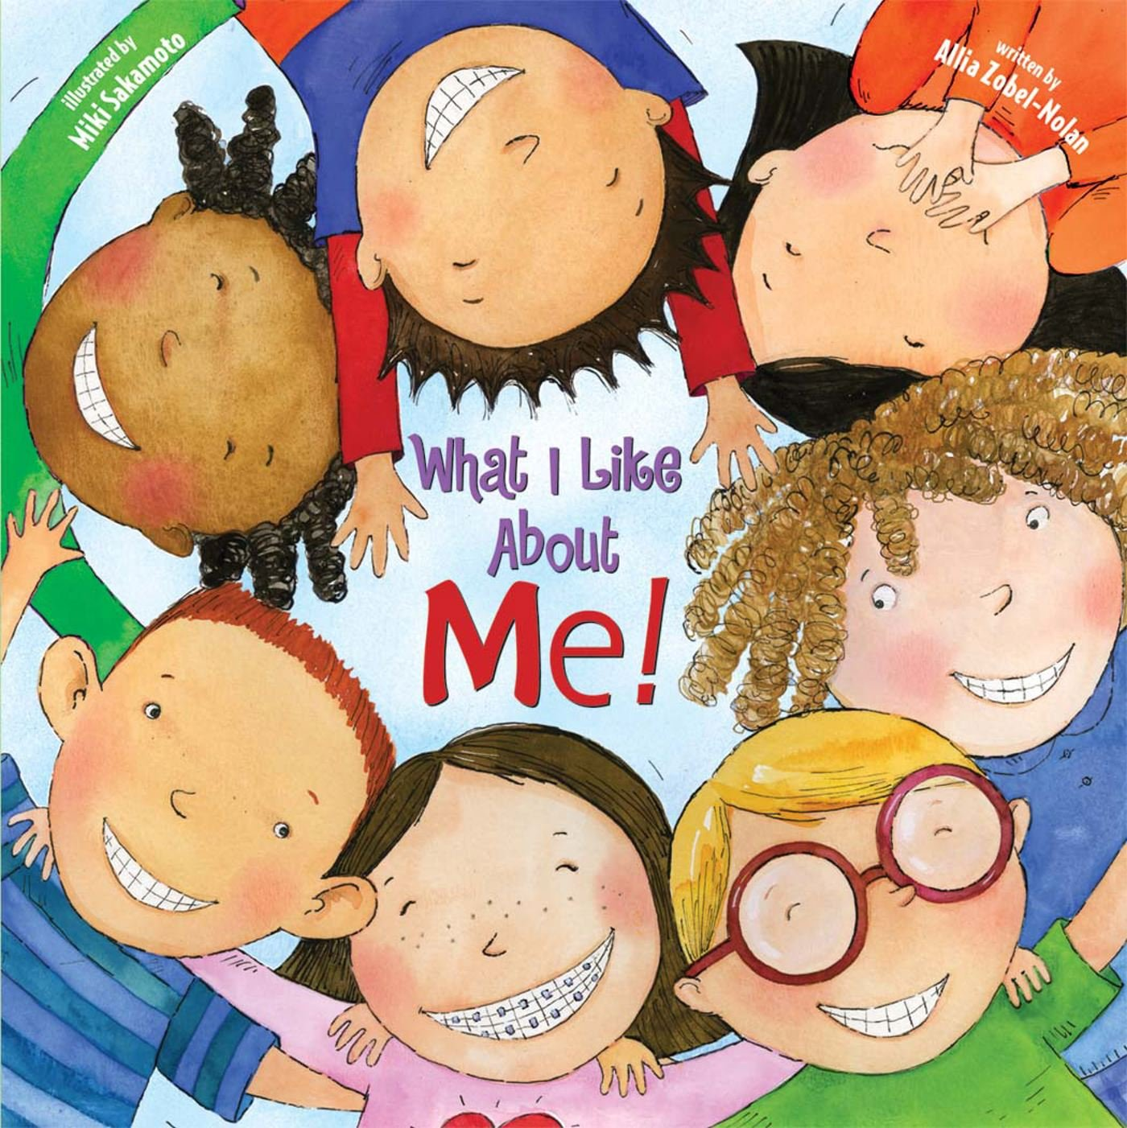
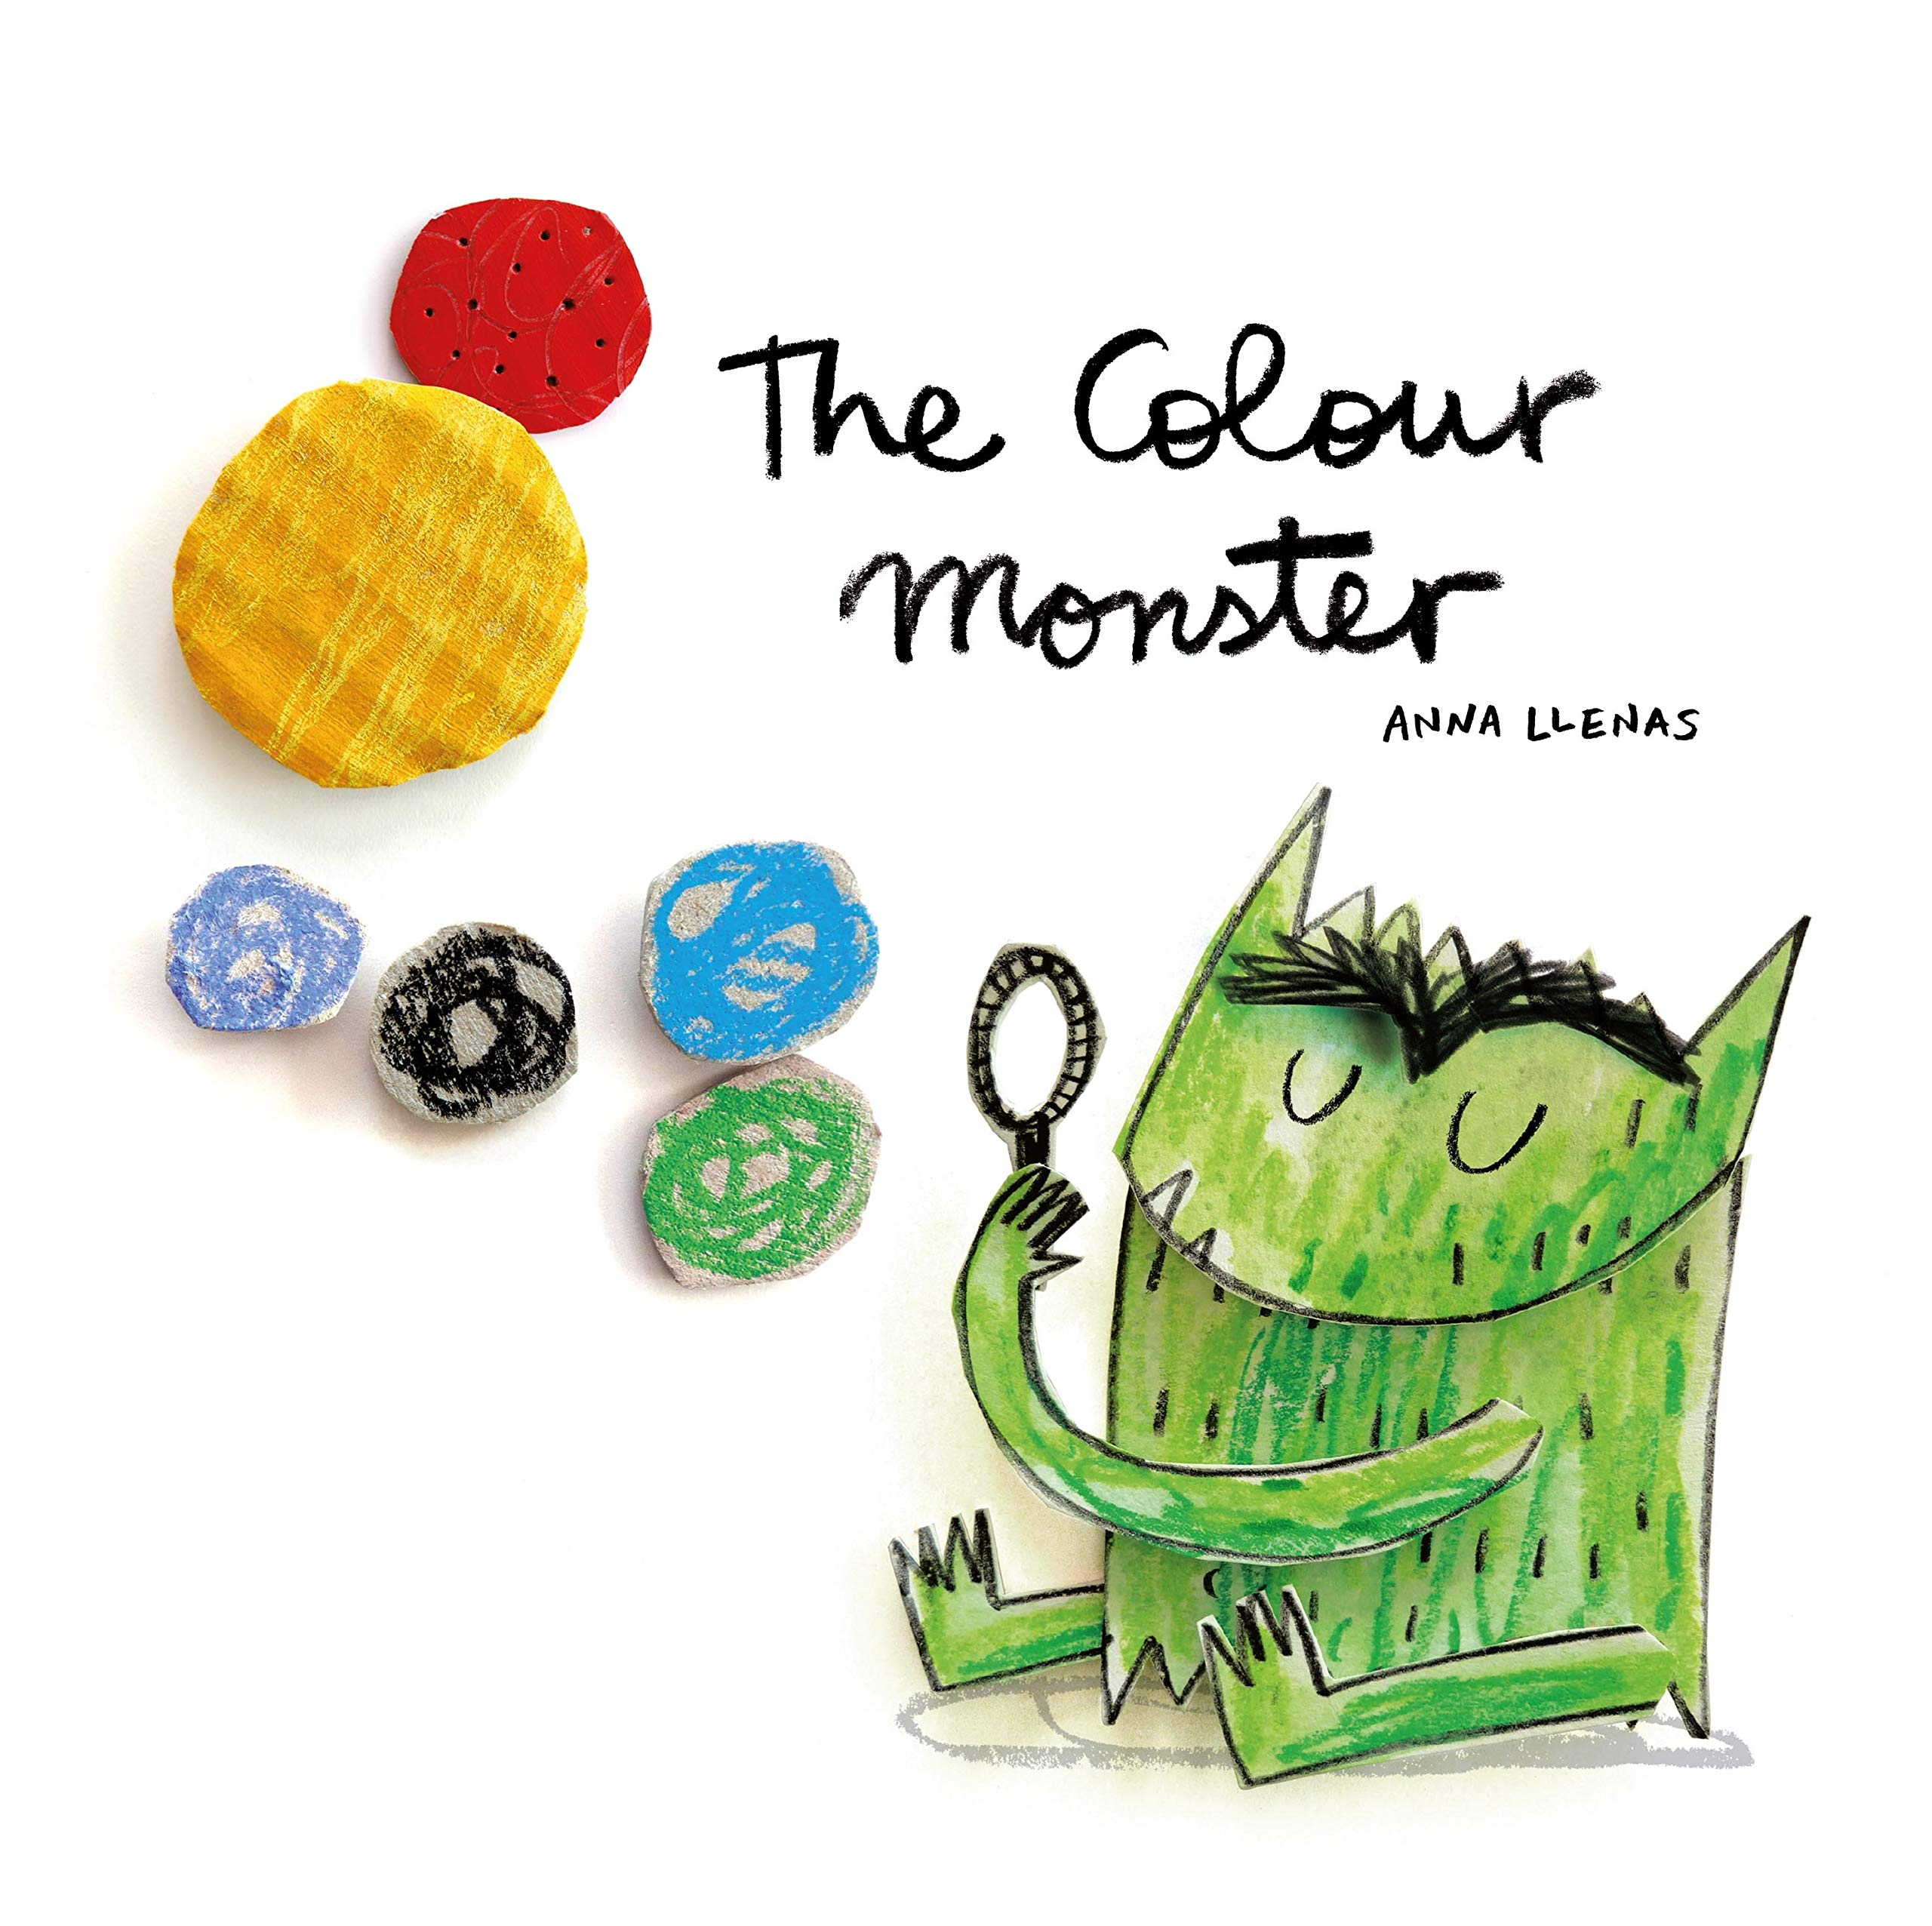
Reception Parent Summary Autumn 2020

The first half of term is focused on settling children into school life and adapting to classroom routines. There will be activities focused on personal, social and emotional development whereby children will be encouraged to establish positive attitudes both of themselves and others, as well as towards learning. We will also be talking about our feelings and helping the children to articulate these and manage them. Some of our Key Texts will include, The Colour Monster, What I like about me, Owl Babies, You Choose, Once there were Giants and Monkey Puzzle amongst a few others!

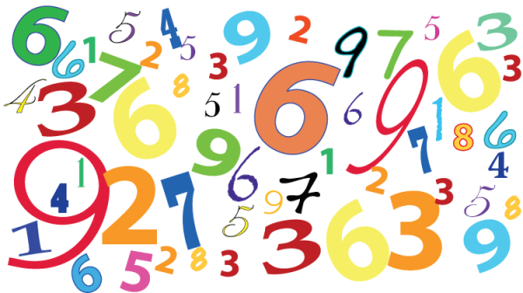
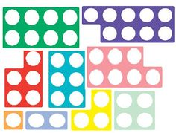
In Communication and Language children will take part in continuous speaking and listening activities in small groups and whole class lessons. Children will be taught phonics through the Letters and Sounds scheme. They will be starting off with Phase 1 activities linked to sounds in the environment.

In Maths we will cover a number of stories, songs and investigative activities which will encourage mathematical understanding. Children will be provided with opportunities to develop an understanding of number, shape, space and measures. Our initial focus will be reciting numbers in order to 10, knowing that numbers identify how many objects are in a set and showing an interest in numbers in the environment. In addition to this, our daily routines will support counting and problem solving. Numicon will be used to consolidate numbers by recognising colours and shapes.

In Understanding the World, our theme will be ‘All about me’. We will support children in talking about themselves and significant events in their own experience, understanding similarities and differences between each other and knowing that some things make them unique. After half term, our theme will change to ‘Christmas’ where children will explore a range of artic animals, seasonal changes and changing environments.

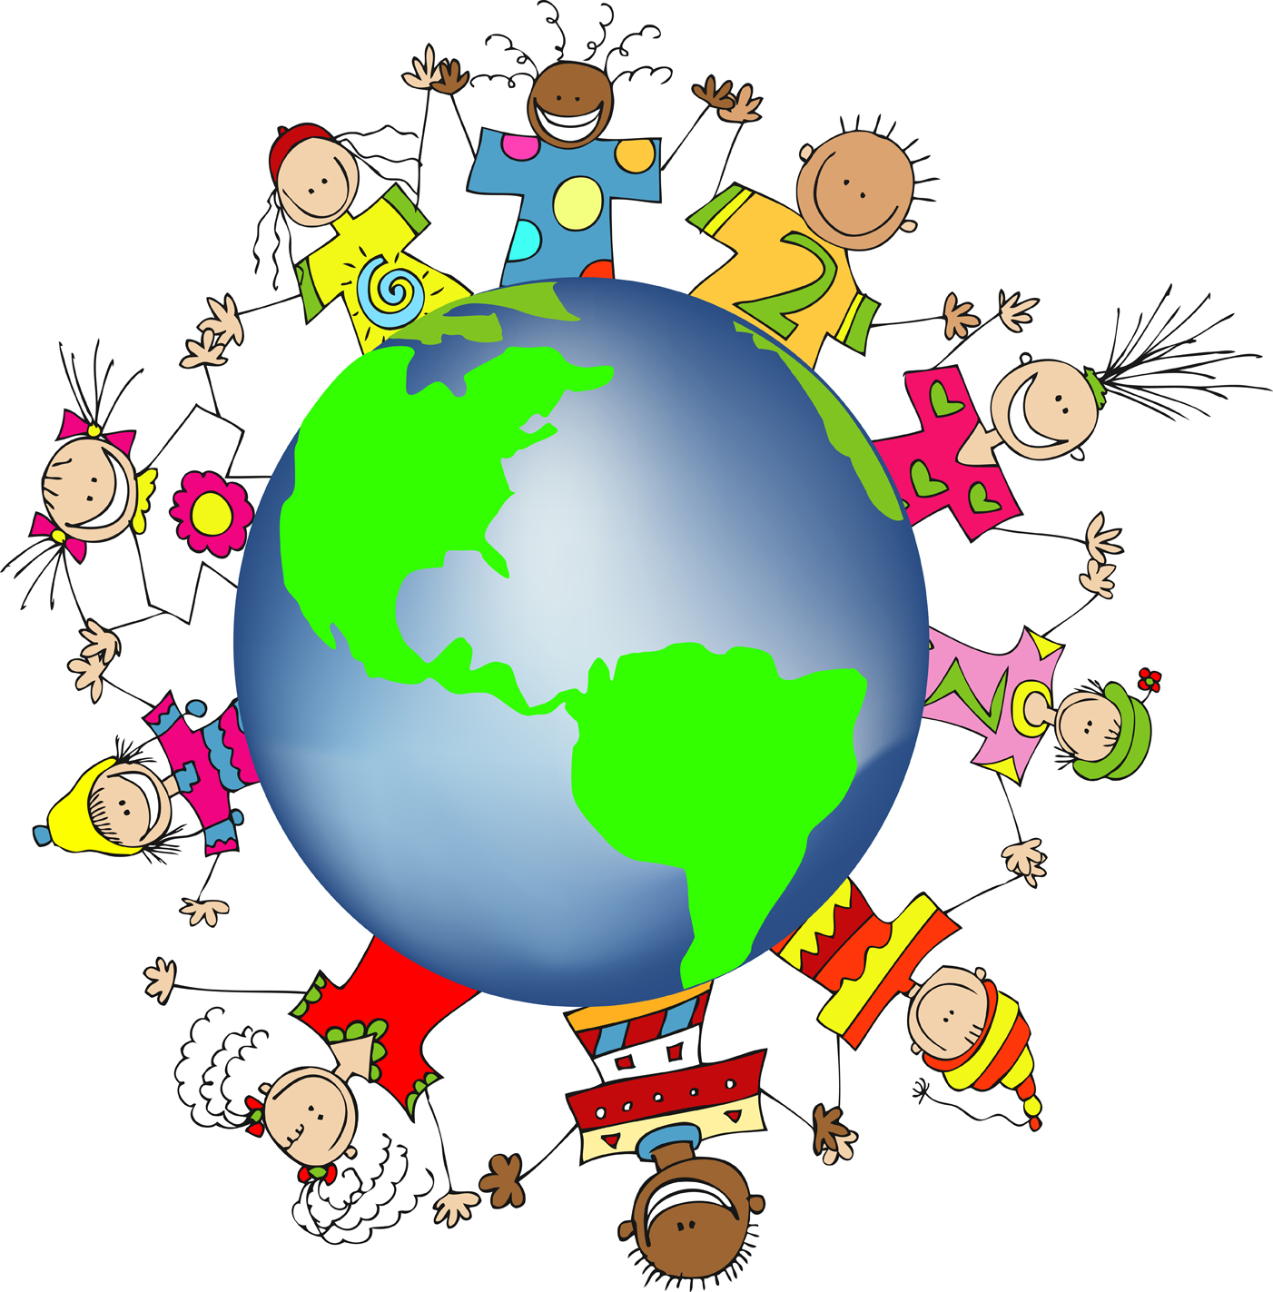
In Physical Development we will support and encourage physical control, mobility and awareness of space, both indoor and outdoor. As part of our Health and Self-care development, children will be encouraged to be independent in dressing and caring for their belongings. We are also focussing on hand washing and personal hygiene.

In Expressive Arts and Design children will be supported in imaginative play and opportunities for singing, dancing, drawing, painting and sensory experiences will be provided. Children will also be participating in cookery activities in preparation for Christmas.

Please remember that this is a brief overview of the plans for the term and if you have any queries do not hesitate to contact us.

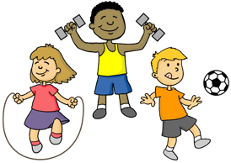
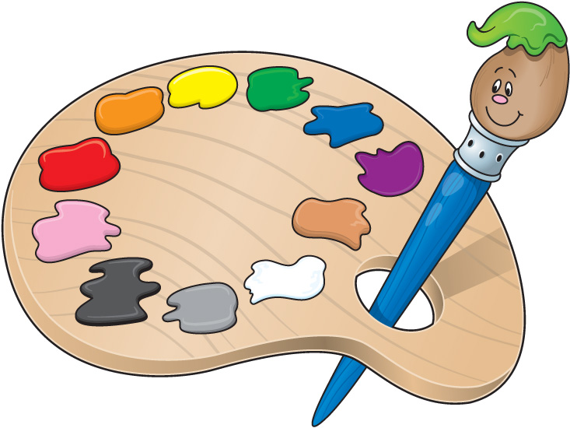
Reception Team

