Year 3 Parent Summary Autumn Term

Welcome to Year 3! We hope you have had a fantastic summer and are rested and ready for work this Autumn term. As you will see we have an exciting term lined up for the children! Miss Lopez and Mr Forbes can’t wait to get started and are really looking forward to working with you.
English
Taking inspiration from the story ‘Ug’ by Raymond Briggs, the children will write across a range of genres including narrative, instructional texts and letters. The children will continue to develop their speaking and listening skills using drama and role play in class. They will also explore a wide range of fiction and non-fiction in guided reading sessions and will have opportunities to discuss their favourite books.
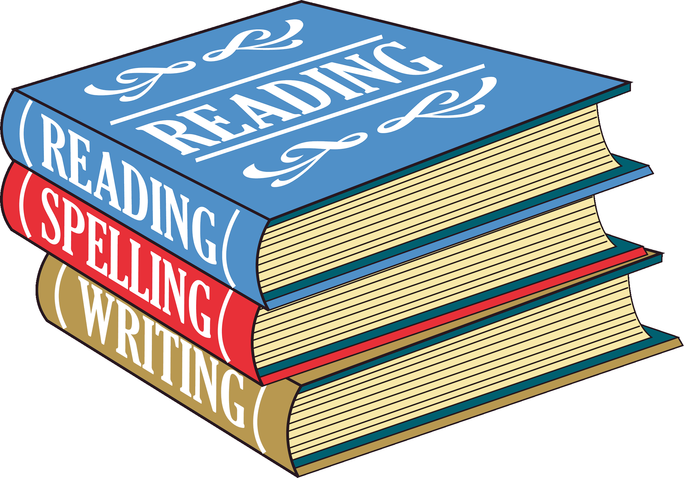
The children will also use dictionaries and learn how to use a thesaurus to develop their vocabulary. They will continue to practise editing their work for punctuation, spelling and content. There will also be a focus to practise cursive handwriting.

Mathematics
The children will continue to use practical equipment, including Numicon, to problem solve in number, money and measurement. They will continue to develop and practise oral and mental skills with a particular focus on times tables.

Further work will be done on learning to tell the time. There will also be regular opportunities for children to take part in maths investigations, developing their mathematical thinking skills and working collaboratively in groups.

Science
In Science, the children will explore and learn about different rock formations and their properties. There will also be an opportunity to create chocolate rocks! After half term, the focus will be on learning about different forces and their effects as well as exploring magnets.

Computing
In Computing the children will learn about e-safety and how to stay safe online. The children will begin to learn coding using a combination of different formats. They will use the internet to research topics and begin to publish their work. They will also use I-pads to explore new learning opportunities and how to work across different apps. Children will also use iMovie to create an animated story.
Humanities
The term will begin with a History focus, learning about life in the Stone Age and Bronze Age. The children will compare life in the modern age to that of past societies and will also have the opportunity to dress up for our ‘Flintstones Day’!

Music
The children will begin to learn the recorder and understand music theory. They will develop their skills in music appreciation and consider the relationship between music, movement and descriptive sound.

Physical Education
In P. E. the children will take part in lessons on games improving their throwing, catching and collaborative skills.
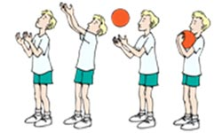

PSHE
In PSHE the children will be discussing the effects of COVID19 and how we are feeling about coming back to school. We will be doing lots of work on transitioning back to routine and discussing how we can support our friends and families too.

Art/Design and Technology
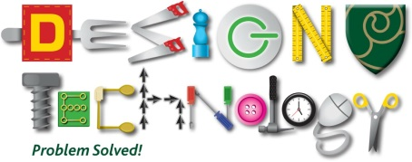
Children will experiment and learn though different techniques and materials. They will show awareness to different kinds of art through study of cave drawings and replicating them. The children will create their own artwork based on early cave and Aboriginal designs.

Please remember that this is just a brief outline of this term’s plans and does not include everything the children will be doing.

