Nursery Parent Summary Autumn Term 2020

Dear parents and carers,
Welcome to all our existing and new parents. It is lovely to have the children back filling the classrooms once again. They have come back to school with excitement and enthusiasm. We have had a great few weeks back and look forward to working with you as a team to provide your child with the best possible nursery experience.
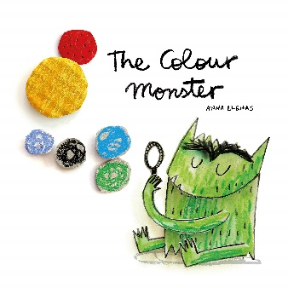
This half term the children’s learning will be focused on the topic ‘All about Me’. This will largely support their Personal, Emotional and Social development as well as their Communication and Language skills as they settle into their new classes and the environment. We will provide opportunities for the children to discuss and express their emotions through Expressive Arts and Design activities, talk about family and share their interests with their new friends. We will do this using a range of texts including The Colour Monster, You Choose and Happy to be Me.
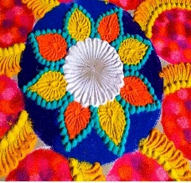
To support children with Understanding the World we will be encouraging the children to explore and observe the changes that take place to the world around them during Autumn by collecting and observing natural items such as conkers, leaves and acorns. We will also provide them with opportunities to explore their bodies, how they grow and how they work. We will revise the children’s own growth from birth to the present. During the second half of this term we will be learning about different celebrations including Diwali, Chinese New Year and of course Christmas!
In Literacy the children will have plenty of opportunities to participate as speakers and listeners. They will learn and recite favourite nursery rhymes and songs and will be reading a variety of core books including Owl Babies, Monkey Puzzle and Brown Bear, Brown Bear. The children will also enjoy creative tasks linked to reading and recognising their own name. In addition, the children will be introduced to Phase 1 of the Letters and Sounds phonics programme.
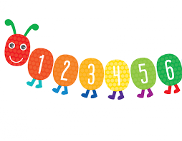
In Mathematics, the children will take part in counting, comparing, matching and sorting activities using everyday objects. Through practical involvement both in and out of the classroom, the children will have the opportunities to develop and understanding of space, shape and measure.
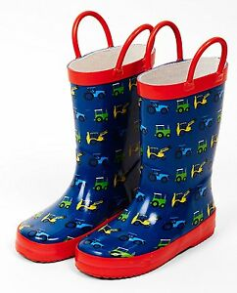
Please ensure all your child’s school uniform including hats, scarfs and gloves are all clearly named. A spare set of named clothes is also essential which will then be kept in their lockers should they need to be changed. Every child will also need a named pair of wellington boots for playing in our woodland area at lunchtime as well as a pair of named PE plimsols for the children’s sessions in the school hall.
Lastly, if you have any questions regarding your child please do not hesitate to contact us.
Thank you,
Mr Jeans, Miss Miller and all the Nursery Team.

