Week Beginning: 18.5.20

St Joseph’s Weekly Science Home Learning Newsletter
I hope you enjoyed Week 1 of our Science Home Learning Newsletter. Welcome to Week 2 which involves another fun experiment for you to try out. Don’t forget to share a picture or video on Twitter with the hashtag #ScienceAtStJosephs or on your class Seesaw pages.

Bouncy Egg Experiment
You will need:
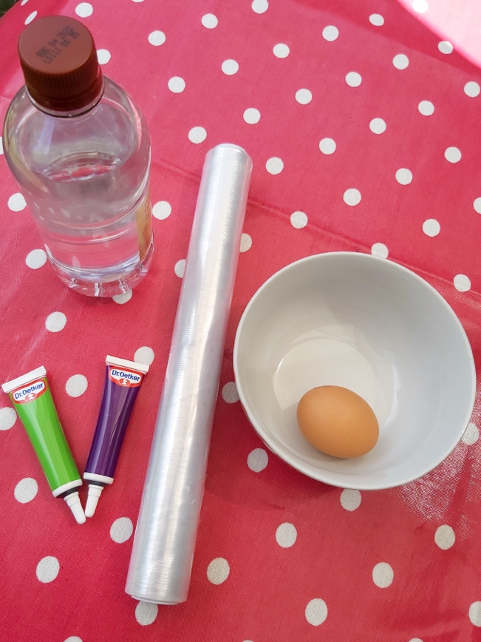
White vinegar
Cling film

Food colouring (optional) – if you want to see the changes in the egg more closely do not add the food colouring
An egg

A bowl or a jar

Method
- First boil an egg. Once the egg is boiled place it in a bowl or a jar and completely cover the egg with vinegar. Mix in a few drops of food colouring to the vinegar if you would like your finished egg to be coloured.
- Then cover the bowl with cling film and leave for 3 to 5 days.
- After 3 days, remove the egg from the bowl and rinse the shell off the egg under a gently running tap. You might have to carefully peel off any excess.
- Now you can test whether your egg bounces, first testing it from a small height.

Questions
- What do you think the vinegar will do to the eggshell and to the inside of the egg?
- What can you see when the egg is in the vinegar?
- What does this experiment smell like?
- Can you explain what has happened in this experiment?
- How high can you bounce the egg before it breaks?

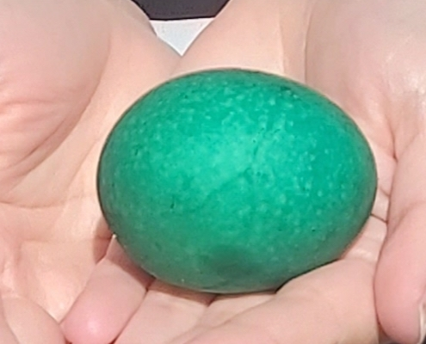
The Science Bit
The vinegar makes the eggshell dissolve. After the eggshell has dissolved, the egg membrane is still protecting the egg. Although it is strong, it is thin, which is why the egg will break when bounced from a higher height.

For KS2 Children
The shell of an egg is made of calcium carbonate. When you place the egg into the vinegar, you see bubbles, which is the chemical reaction of the acid in the vinegar reacting with the calcium carbonate to produce carbon dioxide.

Fun Online Science Resources
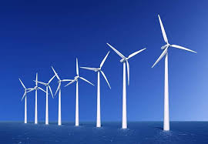
- https://practicalaction.org/schools/wind-power-challenge/#resources – Try out some fun Home Learning STEM challenges from Practical Action. See if you can complete this wind power challenge to build a simple wind turbine that can lift a cup off the floor when powered by a hairdryer!

- This week’s theme for The Great Science Share is ‘National Scavenger Hunt.’ You could try out this at home Spider Safari - https://pstt.org.uk/application/files/7215/8754/4376/Science_Fun_at_Home_5_Spider_Safari.pdf
- Try a ‘Zoom in Zoom Out’ activity on Explorify -https://explorify.wellcome.ac.uk/en/activities/zoom-in-zoom-out/prints Can you guess what it is?

I can’t wait to see the results of your experiment!
Miss Gorman Kiely
Safety Warning
- Get an adult to help you when boiling the egg.
- After touching the egg that has been in the vinegar ensure you wash your hands thoroughly.
- Be careful when bouncing the egg. Do so outside or on a surface that is easy to clean as the egg may break.

