Religious Education
Holy Week

How to use this workbook!

What I think about your ‘work at home’ time!

I think you will have either a book to work in at home, or some paper to work on. I think you will have pencils or pens to write with and maybe some coloured pencils.
I also think you will have access to the internet.

You might have a printer and glue and scissors.
If you have a printer you can print this book off and do the activities using the pages in it, or cut out the pictures and paste them into your book.
If you don’t have a printer, copy what you need into your workbook.

You will need to choose what activities you can do and which ones you can’t! Easier activities are listed first.

This workbook is to help you learn:

1. What happened in the Last Week of Jesus’ life (we call that week Holy Week)

The information is in red: the activities are in black

1. What happened in the Last Week of Jesus’ life (we call that week Holy Week)

EASTER!

Palm Sunday:
5th April

Holy Thursday:
9th April

Good Friday:
10th April

Easter Sunday:
12th May

This year all the events of Easter fall in April. As a Church we remember and celebrate 4 special days in the last week of Jesus’ life. On each day we remember something different that happened to Jesus.

Some things to do!

Have you got a calendar in your house?
- If you can find one, write the names of the Holy Days we will celebrate in April.

Can’t find a calendar?
- See if you can make one! Copy the one above and write the name of the Holy Day onto the correct date.

Have people in your family got mobile phones?
- See if they will set a reminder alarm for the morning of each of the Holy Days.

Let’s learn about each day from the Gospel of Matthew

Remember!
All of the Gospels contain an account of the death and resurrection of Jesus. Each Gospel writer records the events differently, so that it makes sense to the people they are writing for. We need to remember that, for our Church, even though some of the details are not the same, all the Gospel writers tells us the same thing – that Jesus died and then rose from the dead.

Palm Sunday: 5th April

Some things to do! (younger pupils)

1. Watch a video of this story: https://www.youtube.com/watch?v=VIUk0YCi15w
This video is NOT Matthew’s account – but it has all the same parts.

2. Copy the pictures below into your book to record a simple version of what happens.

3. If you had been with Jesus, what would you have thought and felt? Write your ideas in your book.

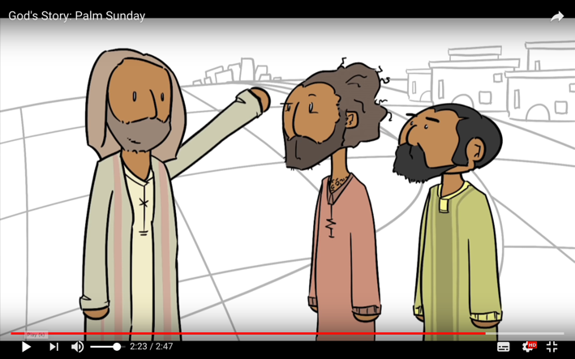
Jesus comes into the village… He sends two of his disciples to get a donkey…
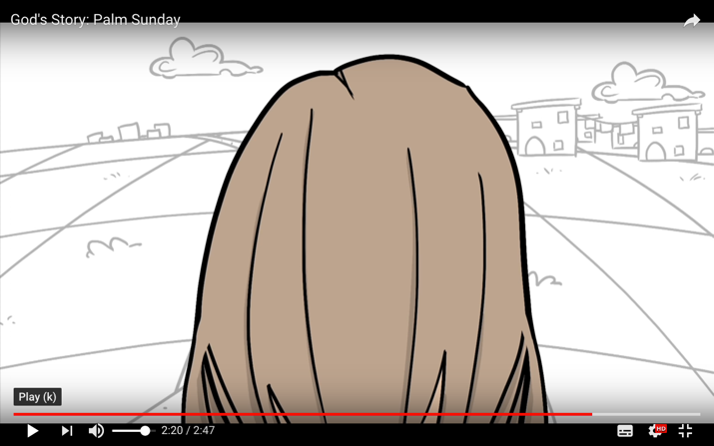

Jesus rides into Jerusalem.
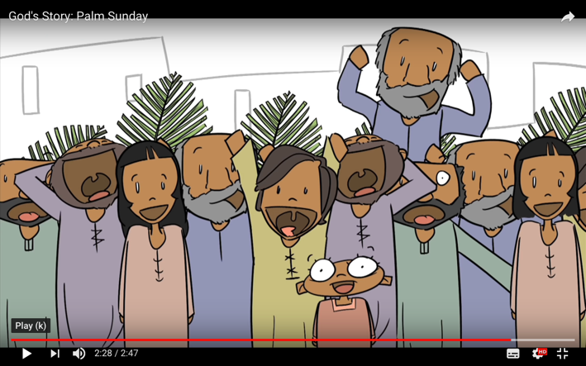
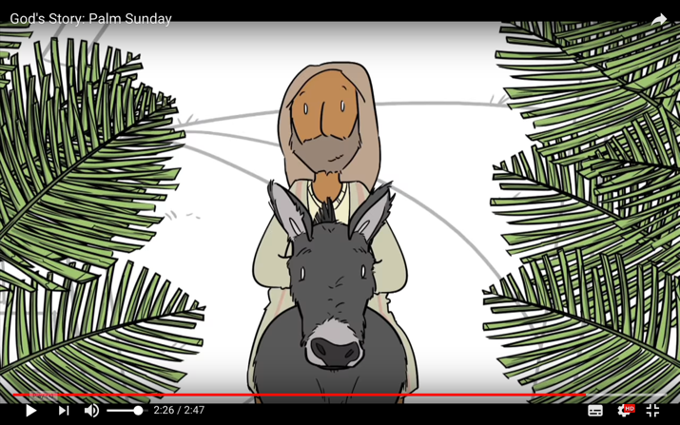
People throw cloaks on the ground and wave branches… the people shout ‘Hosanna!’

(from https://www.youtube.com/watch?v=lTmbTuutBgg)

Some things to do! (older pupils)

1. Read what Matthew’s Gospel tells us.

Matthew 21: 1-10

(scene 1) When they had come near Jerusalem and had reached Bethphage, at the Mount of Olives, Jesus sent two disciples, ²saying to them, ‘Go into the village ahead of you, and immediately you will find a donkey tied, and a colt with her; untie them and bring them to me. ³If anyone says anything to you, just say this, “The Lord needs them.” And he will send them immediately.’

⁴This took place to fulfil what had been spoken through the prophet, saying,
⁵ ‘Tell the daughter of Zion, Look, your king is coming to you, humble, and mounted on a donkey, and on a colt, the foal of a donkey.’
(scene 2) ⁶The disciples went and did as Jesus had directed them; ⁷they brought the donkey and the colt, and put their cloaks on them, and he sat on them. ⁸A very large crowd spread their cloaks on the road, and others cut branches from the trees and spread them on the road. ⁹The crowds that went ahead of him and that followed were shouting, ‘Hosanna to the Son of David! Blessed is the one who comes in the name of the Lord! Hosanna in the highest heaven!’
(scene 3) ¹⁰When he entered Jerusalem, the whole city was in turmoil, asking, ‘Who is this?’ ¹¹The crowds were saying, ‘This is the prophet Jesus from Nazareth in Galilee.’

2. Draw the three scenes in your book. Remember to make sure the characters, the settings (places) are ‘signposted’ and the events are evident. If you have a younger sister or brother at home see if you can tell them the story using your pictures.

3. Watch a video of this story: https://www.youtube.com/watch?v=VIUk0YCi15w
This is NOT Matthew’s account. Make a venn diagram to show what is the same and different between Luke and Matthew’s account.

MATTHEW BOTH LUKE
Holy Thursday: Thursday 9th April

Some things to do! (younger pupils)

1. Watch this video of the Last Supper which Jesus had. We remember this last meal on Holy Thursday.
https://www.youtube.com/watch?v=wYAVu4MR7rc
This video is from John’s Gospel.

2. Look at this screenshot from the video. Draw where you eat at home. Draw your family around this space, eating dinner. Draw in speech bubbles the favourite foods you and each member of your family like to eat.

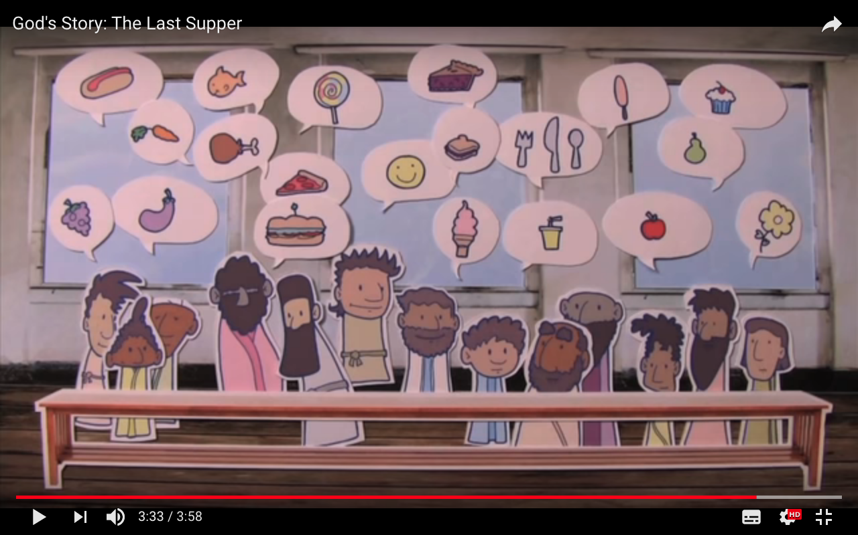

Remember!
The Gospels tell us that the last meal that Jesus had was a Passover meal. Passover remembered the Exodus, when the Israelites escaped from Egypt after the angel ‘passed over’ their homes.
The Passover meal was not a normal meal. People sat at low tables without legs, and lay on cushions on the floor to eat! They ate foods to remember what had happened. Unleavened bread (bread without yeast in it so ‘flat’ bread) and wine were part of the meal.

3. Draw what you think the Last Supper would have looked like. Don’t forget the low table, cushions and bread and wine. Draw Jesus and some of his disciples. If you wan to know the kinds of clothes they wore have a look at www.nazarethvillage.com and watch the home page pictures.

Here is a picture of what someone else thinks the scene would have been like.
Does it look like your picture?
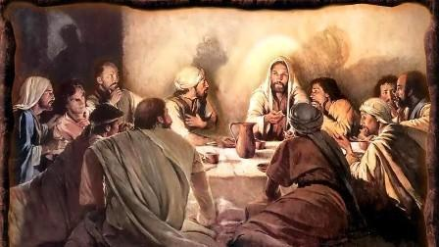

Some things to do! (older pupils)

1. Watch this video of the Last Supper which Jesus had. https://www.youtube.com/watch?v=wYAVu4MR7rc
This video is from John’s Gospel.

2. Compare the video account (from John’s Gospel) and Matthew’s account. Listen to the video, pause it and read what Matthew says. Make a list of the differences between John’s account and Matthew’s.

Matthew 26:17-30

17 On the first day of Unleavened Bread the disciples came to Jesus, saying, ‘Where do you want us to make the preparations for you to eat the Passover?’ ¹⁸He said, ‘Go into the city to a certain man, and say to him, “The Teacher says, My time is near; I will keep the Passover at your house with my disciples.” ’ ¹⁹So the disciples did as Jesus had directed them, and they prepared the Passover meal.

20 When it was evening, he took his place with the twelve; ²¹and while they were eating, he said, ‘Truly I tell you, one of you will betray me.’ ²²And they became greatly distressed and began to say to him one after another, ‘Surely not I, Lord?’ ²³He answered, ‘The one who has dipped his hand into the bowl with me will betray me. ²⁴The Son of Man goes as it is written of him, but woe to that one by whom the Son of Man is betrayed! It would have been better for that one not to have been born.’ ²⁵Judas, who betrayed him, said, ‘Surely not I, Rabbi?’ He replied, ‘You have said so.’

26 While they were eating, Jesus took a loaf of bread, and after blessing it he broke it, gave it to the disciples, and said, ‘Take, eat; this is my body.’ ²⁷Then he took a cup, and after giving thanks he gave it to them, saying, ‘Drink from it, all of you; ²⁸for this is my blood of the covenant, which is poured out for many for the forgiveness of sins. ²⁹I tell you, I will never again drink of this fruit of the vine until that day when I drink it new with you in my Father’s kingdom.’

30 When they had sung the hymn, they went out to the Mount of Olives.

One of the differences
Matthew’s Gospel does not have a key event that John’s Gospel does. Neither does Mark, neither does Luke. John tells us that Jesus washed the feet of his disciples at his Last Supper. Washing the feet of your guests was an action of hospitality – it welcomed people to your home, especially if they had walked a long way on dirt tracks. Usually it was done by a servant or slave – but at the Last Supper, the host of the meal washed the guest’s feet. This would have been startling to those who had their feet washed as well as to those in John’s community who read that Jesus did this.

3. Welcoming people is still an important gesture of hospitality.
Think about your life.
- How does your family welcome people who are coming to visit you at home?
- How does your school welcome new pupils?
- How have you been welcomed?

Draw a picture of ONE situation (above).
Include:
- What you say
- What you do.

Good Friday: Friday 10th April

Some things to do! (younger pupils)

On Good Friday we remember that Jesus died on a cross.
In the time of Jesus the Romans killed people by putting them on a cross. We remember the death of Jesus when we make and see crosses.
Good Friday is a sad, quiet day, even though we know that Jesus will rise again on Sunday. Some people think that Good Friday used to be called God-Friday, but that over time the name has changed.

1. Find any kind of paper at home; old magazines, newspapers, old paper even with writing on it.
Use your ruler to draw 2 rectangles on one piece of paper: make one rectangle 4cms by 20 cms and another one 4cms by 12 cms. Cut these rectangles out and make them into a cross. If you can, glue or staple them into the cross shape. Now make 2 more crosses out of different paper!
Look for places in your house you can put your three crosses. Have you any blue tack, or a magnet on the fridge, or a pin in a notice board? If you have glue, glue each cross to a piece of paper and put it on your front door or window on Good Friday.

2. Find your favourite toy or book. Hid it away as if it were in a tomb by placing it in a box or wrap it in paper or put it high in a cupboard. Leave it there till Easter Sunday – when it can ‘rise’ – just as Jesus did!

Some things to do! (older pupils)

1. Watch this video of a lego Easter. Read the events. https://www.youtube.com/watch?v=-M8Yesnt1V8
Stop after Jesus is placed in the tomb.

2. Make a story-map of the events. Either draw what happens in your book, or pause the video and screen shot key moments and electronically paste them into this workbook at the end.

3. What does the video say that people say (speak) as Jesus is on the cross. Write down what the video includes. (Pause the video as you write).

4. Now look at Matthew’s account of Good Friday (below).

- Highlight what Matthew tells us that people say?

- Is it the same as the video?

- Copy Matthew dialogue (what people say) into speech bubbles in your book. Remember to write who says what!

- Sort the comments: who praises Jesus? Who criticises him? Write your own speech bubble: what would you have said?

Extension!
- Matthew puts Jesus’ actual words in Aramaic. Copy them into your book.

- Why might a translator (someone who translates the Bible into English) leave those words in Aramaic?

Matthew 27: 32-50

32 As they went out, they came upon a man from Cyrene named Simon; they compelled this man to carry his cross. ³³And when they came to a place called Golgotha (which means Place of a Skull), ³⁴they offered him wine to drink, mixed with gall; but when he tasted it, he would not drink it.

³⁵And when they had crucified him, they divided his clothes among themselves by casting lots; ³⁶then they sat down there and kept watch over him. ³⁷Over his head they put the charge against him, which read, ‘This is Jesus, the King of the Jews.’

38 Then two bandits were crucified with him, one on his right and one on his left. ³⁹Those who passed by derided him, shaking their heads ⁴⁰and saying, ‘You who would destroy the temple and build it in three days, save yourself! If you are the Son of God, come down from the cross.’ ⁴¹In the same way the chief priests also, along with the scribes and elders, were mocking him, saying, ⁴²‘He saved others; he cannot save himself. He is the King of Israel; let him come down from the cross now, and we will believe in him. ⁴³He trusts in God; let God deliver him now, if he wants to; for he said, “I am God’s Son.” ’
⁴⁴The bandits who were crucified with him also taunted him in the same way.

45 From noon on, darkness came over the whole land until three in the afternoon. ⁴⁶And about three o’clock Jesus cried with a loud voice, ‘Eli, Eli, lema sabachthani?’ that is, ‘My God, my God, why have you forsaken me?’

⁴⁷When some of the bystanders heard it, they said, ‘This man is calling for Elijah.’ ⁴⁸At once one of them ran and got a sponge, filled it with sour wine, put it on a stick, and gave it to him to drink. ⁴⁹But the others said, ‘Wait, let us see whether Elijah will come to save him.’ ⁵⁰Then Jesus cried again with a loud voice and breathed his last.

Easter Sunday: Sunday 12th April

Some things to do! (younger pupils)

In the time of Jesus people were not buried the way we are now.
After someone died their body was wrapped in cloths and placed in a tomb – a cave – on a kind of table. It would lie there for a long time. The women in the community used to place spices and perfumes around the body. For Jesus, this loving action could not be done on the Sabbath day, it had to wait until the Sabbath (Saturday) was over. So, the women who go to the tomb early are the first people to hear that Jesus had risen from the dead!

1. Watch this video https://www.youtube.com/watch?v=l8JX3QgK_iw
This video is NOT Matthew’s account – it mixes different writer’s accounts.

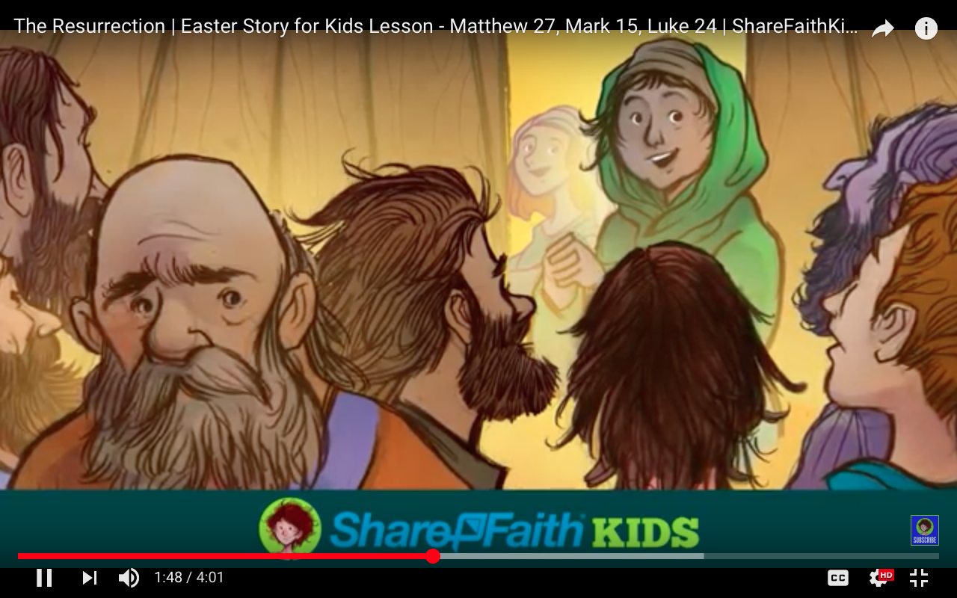

2. Mary rushes in to tell the disciples that Jesus was alive! They didn’t believe her at first.
How do you think Mary would have felt?
- About seeing Jesus alive?
- About the other disciples not believing her?
- If you had some really exciting news to tell, who would you go to first?

3. Go around your house and take down the crosses you made to remember Good Friday.
The tomb stone would have been in the shape of a circle, like a coin. Trace around some coins, colour them bright yellow, and make them into smiley faces! Write the reason for the smile: Jesus has risen!

Some things to do! (older pupils)

Some information about the characters in Matthew’s account of the resurrection.
Mary Magdalene.
Mary Magdalene was one of the women disciples of Jesus. She is the only person named in all the accounts of the resurrection. She was the first one to know that Jesus had risen from the dead. Mary Magdalene is named after the place she lived in: Magdala, on the western shore of Lake Galilee. Her village was known for preparing the fish, caught on the lake, for sale and for drying and salting the fish so that it kept without going bad.

Guards.
Matthew is the only gospel writer who tells us that two guards were put by the tomb to stop anyone stealing the body. This detail is not in any other Gospel account, so we wonder if this was being talked about in Matthew’s community. It would mean Jesus did not rise from the dead and so was not the Messiah.

1. Read Matthew 27: 66-66 and Matthew 28:1-15

The next day, that is, after the day of Preparation, the chief priests and the Pharisees gathered before Pilate ⁶³and said, ‘Sir, we remember what that impostor said while he was still alive, “After three days I will rise again.” ⁶⁴Therefore command that the tomb be made secure until the third day; otherwise his disciples may go and steal him away, and tell the people, “He has been raised from the dead”, and the last deception would be worse than the first.’ ⁶⁵Pilate said to them, ‘You have a guard of soldiers; go, make it as secure as you can.’ ⁶⁶So they went with the guard and made the tomb secure by sealing the stone.

Matthew 28: 1-15
28 After the sabbath, as the first day of the week was dawning, Mary Magdalene and the other Mary went to see the tomb. ²And suddenly there was a great earthquake; for an angel of the Lord, descending from heaven, came and rolled back the stone and sat on it. ³His appearance was like lightning, and his clothing white as snow. ⁴For fear of him the guards shook and became like dead men. ⁵But the angel said to the women, ‘Do not be afraid; I know that you are looking for Jesus who was crucified. ⁶He is not here; for he has been raised, as he said. Come, see the place where he lay. ⁷Then go quickly and tell his disciples, “He has been raised from the dead, and indeed he is going ahead of you to Galilee; there you will see him.” This is my message for you.’

⁸So they left the tomb quickly with fear and great joy and ran to tell his disciples.

⁹Suddenly Jesus met them and said, ‘Greetings!’ And they came to him, took hold of his feet, and worshipped him. ¹⁰Then Jesus said to them, ‘Do not be afraid; go and tell my brothers to go to Galilee; there they will see me.’

11 While they were going, some of the guard went into the city and told the chief priests everything that had happened. ¹²After the priests had assembled with the elders, they devised a plan to give a large sum of money to the soldiers, ¹³telling them, ‘You must say, “His disciples came by night and stole him away while we were asleep.” ¹⁴If this comes to the governor’s ears, we will satisfy him and keep you out of trouble.’ ¹⁵So they took the money and did as they were directed. And this story is still told among the Jews to this day.

2. Find out about Magdala now.
a. Google maps: Magdala. Click the satellite image so you see the screen below.

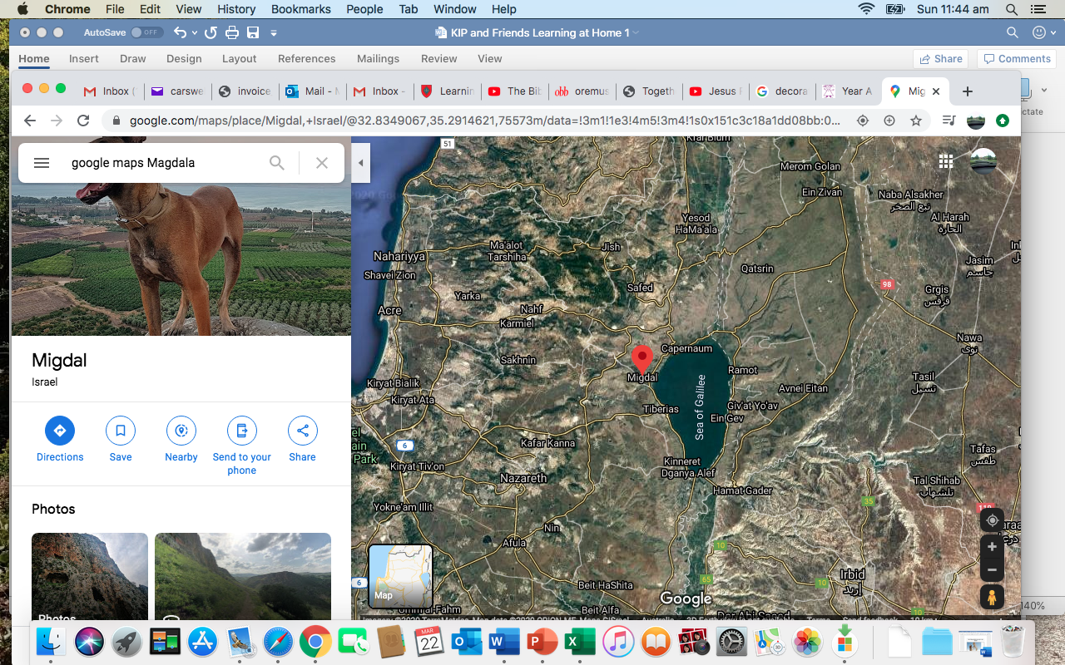

Find some places you should know: they might already be on the map or you can search for them in the search bar on the left (where google maps Magdala is in the picture).

Nazareth – where Jesus lived.
Cana – where Jesus turned water into wine
Tiberias – the capital of the region of Galilee
Capernaum – where John had a house
The Mount of the Beatitudes – where we remember the Sermon on the Mount

b. Do some research: (magdala.org)
- What does the word Magdala mean?
- The women’s atrium (an open-roofed room or hall) remembers Mary and 6 other women who followed Jesus. Write down the names of the other women remembered in this place. The last pillar remembers women of faith now. Who do you know who is a woman of faith? Write a letter to thank her for what she teaches you in her words and actions. https://www.magdala.org/visit/duc-in-altum/womens-atrium/

2. Let’s do some serious thinking.
- Matthews community (the people Matthew wrote for) were having an argument with the leaders of the synagogue (Jewish place of worship) about whether Jesus was the messiah or not.
- How do the guards at the tomb help Matthew to show that Jesus was the messiah?

To finish with…(older pupils)

Of course, the special days we remember are only some of what happens that week.
You might like to know what happens in between the days we remember and celebrate. If you want to hear the whole story, listen to me reading an audio file about this event. Or watch me drawing my version of the story.

Video: https://www.youtube.com/watch?v=e6CabFom2xg&feature=youtu.be
Start the video at 4.59! (if you don’t want to hear me talking to your teachers!

Audio files:
Chapter 26 https://www.youtube.com/watch?v=vBcvWO3bVUM&feature=youtu.be

Chapter 27 https://www.youtube.com/watch?v=NR20b7Tgaxo&feature=youtu.be

Scene 1: Jesus travels from around Lake Galilee, where he has been teaching and healing, to Jerusalem.

Scene 2: He arrives in Jerusalem and a huge crowd gather to meet him. He goes into Jerusalem on a donkey and the people wave branches to greet him. (We remember this event on Palm Sunday)

Scene 3: Jesus goes to the Temple mount – an area around the Temple where people used to gather and meet. Some of the leaders of the Jewish people argue with Jesus about the things he has said: he is asked to explain what he has done and said. The Jewish authorities plot to arrest and kill him.

Scene 4: Still in Jerusalem. It is Passover time when Jews gather to celebrate their escape from Egypt. Matthew tells us that Jesus gathers with some of his disciples to celebrate the Passover meal. (We remember this event on Holy Thursday). After the meal is finished Jesus and some of the disciples go out to the Garden of Gethsemane to pray. Judas and some of the Jewish leaders and guards come to arrest Jesus. He is taken to the Jewish leader’s house and tried for ‘blasphemy’ – for misusing God’s name.

Scene 5: Next morning Jesus is taken to Pilate’s house where he is tried by Pilate for being a King – the King of the Jews. Pilate sentences him to be crucified. He is taken out to a hill and killed. Jesus dies at 3 o’clock in the afternoon. (We remember this event on Good Friday)
Joseph of Arimathea takes the body of Jesus down and places it in a tomb. The Romans place two guards in front of the stone entrance way to stop anyone stealing the body of Jesus.

Scene 6: The women go to the tomb to place spices and fragrances around it. It has gone. He is risen! (This event is studied in the Easter to Pentecost framework.)

1. Make a Chatterbox. Fill it with questions and answers about Easter.
Instructions online! https://www.youtube.com/watch?time_continue=73&v=OGVkIVWJ0i8&feature=emb_logo&disable_polymer=true

