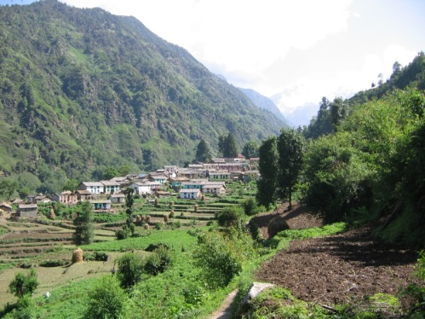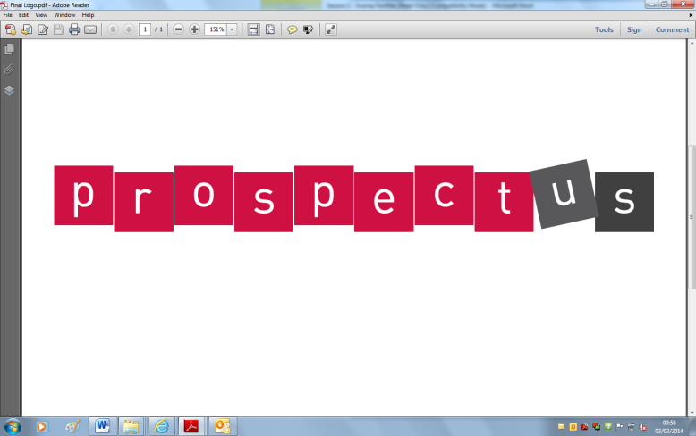[](http://www.google.co.uk/url?sa=i&rct=j&q=&esrc=s&frm=1&source=images&cd=&cad=rja&docid=JfG062VubuibnM&tbnid=E93l0zmrsm58yM:&ved=0CAUQjRw&url=http://www.beeskneesdance.com/the-full-season-knock-out-draw/pow/&ei=AKQ1UoSHEMextAaq_IDoBA&psig=AFQj)

***Choose projects to achieve your minimum***

***5 POWer Points.***

***By all means go over 5points!***

***Tick off what you have completed to achieve your points.***

**After the Easter break we will be learning about:**

***‘*Life in an Indian Village’   
(select a village to focus your project on)**

**Extend your research and ICT skills:**

* Find out what people do in the village you have selected. - **2 points.**
* Find out if there are any famous buildings or landmarks in the village - **2 points.**

**Explore your mathematical skills:**

* Find out about the climate of the village**.** Can you collect any information about the rainfall there? - **2 points.**
* Make a comparison in size to the village you have chosen and to the area that you live in. How many people live in each place? What does this tell you about the size? - **2 points.**
* Explore symmetry and make a rangoli pattern.—**2 points.**

**Develop your creativity:**

* Design the Indian flag with a twist! Adapt it to show some of the key features of your village - **2 points.**
* Make a 2D map or a 3D model of your Indian village. Can you show physical and human features? – **3 points.**
* Create your own henna,   
  rangoli or traditional outfit design (choose one, two or all three!) - **3 points each.**

**Explore your chosen village**

* What special festivals or celebrations are important in the village? Do the people retell any of the Indian God stories? - **2 points.**
* Find out if there are common animals/plants in your village? - **2 points.**