Before 9am | Wake up | Eat breakfast, make your bed, get dressed
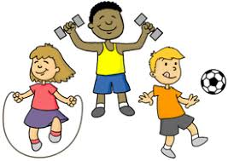  9.00 – 10.00 | Physical Activity | Internet search for Kids yoga, HIIT sessions, Kids Workouts
10.00 – 11.00 | Academic Time | NO ELECTRONICS  Diary Writing, Phonics/Comprehension, Maths
11.00 – 12.00 | Creative Time | Drawing, Crafting, Music, Cooking/Baking
12.00 – 12.30 | LUNCH
12.30 – 1.00 | Chore Time | Wipe down all tables, surfaces, chairs  Wipe all door handles, light switches, remote controls, phones  Wipe around all sinks and toilets
1.00 – 2.00 | Quiet Time | Puzzles, Word Searches, Reading, Nap
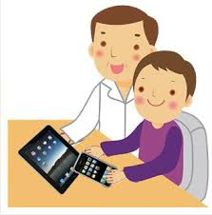  2.00 – 3.30 | Academic Time | ELECTRONICS ALLOWED  iPad games, online learning, completing of work from previous session
Home Learning Daily Schedule

