**Year 1 Parent Summary Autumn Term**

Welcome to Year 1. We hope that you have enjoyed the holidays and all of the children are rested, relaxed and ready for this exciting new term. We are really looking forward to getting to know all of the new Year 1 children. **Below is a brief summary of some of the areas the children will be studying during the Autumn term. Our main topics this term are ‘Children’s Interests’ and ‘Toys from the past’.**



**Religious Education** – See separate information sheet.

**English**

In English we will be learning about traditional fairy tales as well as stories

from other cultures. In our non-fiction work we will learn how to write instructions, labels, lists and captions. Throughout the term we will be encouraging children to participate as speakers and listeners during whole class teaching, group discussions and partner work.

Reading is a very important part of the Year 1 curriculum and the children will be provided with a reading book at the appropriate level to take home each week. Please ensure that the children practice reading this book at home every day. In Phonics we will start with a quick recap of the phase 3 sounds before concentrating on securing phase 4 and 5 phonic sounds in their reading and writing. This term our focus will be on consolidating children’s letter formation, spacing and sizing in preparation for next term when we will begin to introduce joined handwriting.

[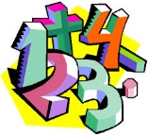](http://www.google.co.uk/imgres?q=numbers&um=1&safe=active&hl=en&biw=1280&bih=929&tbm=isch&tbnid=IaZNfY7HlXl2ZM:&imgrefurl=http://www.numberwatch.co.uk/&docid=XHRC_Yeqv7InkM&imgurl=http://www.numberwatch.co.uk/bd05092_.gif&w=399&h=362&ei=GkLmUc7eOs-v7Aaq9oHoAw&zoom=1&ved=1t:3588,r:3,s:0,i:89&iact=rc&page=1&tbnh=183&tbnw=202&start=0&ndsp=23&tx=108&ty=69)**Mathematics**

In Numeracy the children will continue to work on number recognition, ordering numbers and the correct formation of their written numbers. We will be looking at place value (tens and ones) using practical activities in order to partition two-digit numbers. They will use practical resources to learn about addition and subtraction and they will begin to learn their number bonds for numbers up to 10. In addition to this, the children will explore number and shape patterns. They will also begin to learn how to use a number line and 100 square when solving number sentences. **We will continue to use Numicon and a range of other resources to support and engage pupils in the joy of Mathematics.**

[](http://www.google.co.uk/url?sa=i&rct=j&q=maths&source=images&cd=&cad=rja&uact=8&ved=0CAcQjRw&url=http://en.wikipedia.org/wiki/File:Operators_(maths)_linear.svg&ei=Y3gVVdbmA4XwaMmfgNAD&bvm=bv.89381419,d.d2s&psig=AFQjCNGharc-TKBibN7biwDQUxE1jKR5oQ&ust=1427556832424822)

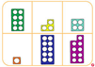

**Science**

In Science we will be learning about ‘Materials’ and ‘Seasons’ throughout Autumn term.In our ‘Materials’ topic we will be investigating different materials their properties and uses. The children will investigate, describe and sort various materials. The children will also learn to observe the changes across the four seasons and look at how the weather and our surrounding environment vary. They will be introduced to some basic scientific vocabulary related to materials.

**Computing** [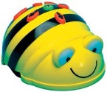](https://www.google.co.uk/url?sa=i&rct=j&q=&esrc=s&source=images&cd=&cad=rja&uact=8&ved=0CAcQjRxqFQoTCLjTnJCK2sYCFcFp2wodZAoFLw&url=https://www.pinterest.com/ammeleary/bee-bots/&ei=kbekVfjGG8HT7QbklJT4Ag&bvm=bv.97653015,d.ZGU&psig=AFQjCNE0J55vEf1gq3s4sN5GfTliJs15mA&ust=1436944634232380)[](http://www.google.co.uk/url?sa=i&rct=j&q=&esrc=s&source=images&cd=&cad=rja&uact=8&ved=&url=http://www.123rf.com/photo_9353062_cartoon-smiling-desktop-computer--vector-illustration.html&ei=AbekVZyJGcqy7QbC8ZfQCA&bvm=bv.97653015,d.ZGU&psig=AFQjCNGeEWtJZT9SGYWsN_tQH6-HYvcLdw&ust=1436944513833921)

The children will continue to develop basic keyboard and mouse skills.They will use simple software to enter data to create graphs or pictograms. The children will also get the opportunity to use a variety of different ICT based technologies to take photographs and edit basic information. In addition to this the children will be introduced to computing and using BeeBots to create simple algorithms.

**Art & Design Technology**

1. [](http://www.google.co.uk/url?sa=i&rct=j&q=&esrc=s&source=images&cd=&cad=rja&uact=8&ved=0CAcQjRxqFQoTCPSMt9CO2sYCFcYW2wodglML6Q&url=http://www.clker.com/clipart-1978.html&ei=SbykVbTEM8at7AaCp63IDg&bvm=bv.97653015,d.ZGU&psig=AFQjCNFZwGwAcXOev0oWDn5o-QWF_9euQQ&ust=1436945835980592)

In Art the children will explore various media and colour mixing techniques

through illustrating their own characters and personal interests. In Design

Technology the children will design and create their own toy.

**Humanities**

In Geography we will be learning about our local area. **The children will learn how to locate different places on a map.** In History the children will learn about people, places and toys from the past. We will discuss what they were made from and why they were they were popular at the time.

[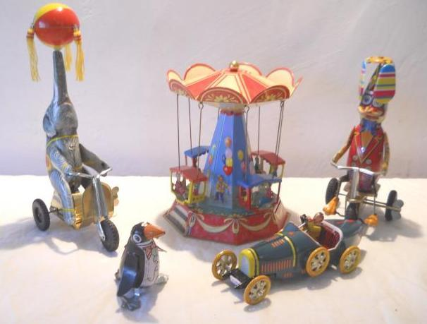](http://www.google.co.uk/url?sa=i&rct=j&q=&esrc=s&source=images&cd=&cad=rja&uact=8&ved=0CAcQjRxqFQoTCLDFkImO2sYCFa0K2wods4UMvQ&url=http://www.getthespecialists.co.uk/toys_past.html&ei=tLukVbCbE62V7Aazi7LoCw&bvm=bv.97653015,d.ZGU&psig=AFQjCNGApAFHhcUvgzl9elr1bKLFVdFuOw&ust=1436945714286820)

**Music**

In Music we shall be exploring different sounds and their duration. The children will learn a variety of songs developing their sense of pitch and rhythm. They will also have the opportunity to play different tuned and unturned musical instruments. The children will take part in singing assemblies weekly and will perform to the whole school in our half term ‘St Joseph’s the Musical’.

[](http://www.google.co.uk/url?sa=i&rct=j&q=&esrc=s&source=images&cd=&cad=rja&uact=8&ved=0CAcQjRxqFQoTCLuihZ-P2sYCFcOZ2wodDfwAkg&url=http://www.ekcsk12.org/Domain/88&ei=7rykVbvzKsOz7gaN-IOQCQ&bvm=bv.97653015,d.ZGU&psig=AFQjCNGBUQ6MzhDLmqZ5O4uI7aZ5wNTNng&ust=1436946023033112)

**PSHE**

In PSHE we will learn about new beginnings and develop our speaking and listening skills during circle time activities. They will also learn about keeping safe online and offline; the importance of keeping personal information secure and how to use a computer responsibly.

[](http://www.google.co.uk/url?sa=i&rct=j&q=&esrc=s&source=images&cd=&cad=rja&uact=8&ved=0CAcQjRxqFQoTCKe8-YiR2sYCFQVa2wod4Z8Axg&url=http://www.tewkesbury-primary.co.uk/parent-information/e-safety/&ei=2b6kVefrDoW07Qbhv4KwDA&bvm=bv.97653015,d.ZGU&psig=AFQjCNHI4wZX48EypaTdl2B9BYs9nAp8Ug&ust=1436946517890314)

**Please remember that this is only a brief outline of what your child will be learning about during this term.**