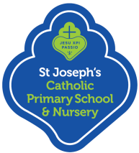  Term | Re Topic | Caritas  Please note that Caritas on Friday afternoons (1pm-3pm) should be linked to the Stay and Learn/Play on that morning. | Liturgical Feasts | Display  Colours &  Prayer Table  Ideas
Autumn  1 | Beginning with God | Family & Community  Friday 12th October 2018 | 7th Oct - Education Sunday | Display – Green  September: Green cloth, School Mission Statement, crucifix.  October: Green cloth. Harvest festival. Non-perishable food items, meal-time prayers, stalks of wheat, Chalice, Paten, crucifix.
Autumn  2 | Advent to Christmas | Option for the poor and vulnerable  Friday 14th December 2018 | 1st Nov – All Saints Day  2nd Nov – All Souls Day  2nd Dec – First Sunday of Advent | Display – Purple  November: Green cloth. All Souls. Poppy/ies, basket of names the children want to pray for, a class remembrance book, sympathy card, Icon, crucifix.  December: Purple cloth for advent, advent wreath, advent calendar, holly, nativity scene (without baby Jesus) crucifix, Christmas cards that children made (religious scenes only)
Spring  1 | Being a Sacramental People | The Dignity of Work  Friday 8th February 2019 |  | Display – Green  January: White cloth or gold (Epiphany), wrapped boxes as gifts from the wise men, figurines of wise men, Icon, crucifix.  February: Purple cloth for Lent, Lenten tree with promises from children, example of Lenten calendar, crucifix.
Spring  2 | Lent to Easter | Dignity of the Human Person  Friday 22nd March 2019 | 6th March – Ash Wednesday | Display – Purple  March/April: Crucifix, Stations of the Cross, Chalice, Paten, Bible, candle, Easter cards that the children have made (Religious scenes only) Please change crucifix to Salvadorian cross and stations of the cross to baptismal candle and baptism card after Easter.
Summer  1 | Easter to Pentecost | Solidarity and the Common Good  Friday 17th May 2019 |  | Display – Green  May: Could have blue cloth, picture/statue of Mary, rosary beads, flowers, pictures of children’s mothers, prayers to Our Lady, Salvadorian cross, confirmation card and certificate, holy communion card and certificate (or June for communion).  June: Red cloth, Pentecost, Holy Spirit images, Fathers, pictures of children’s fathers.
Summer  2 | A Virtuous Life | Stewardship  Friday 12th July 2019 | 9th June – Pentecost Sunday | Display – Green  July: Holiday objects such as pebbles, seashells, postcards.

Other ideas - Glass beads, stones, bark, photos.
Symbols of the seasons:-red poppy, autumn leaves, sea shells.

**Throughout the year, there must be a crucifix or Salvadorian cross and bible (‘My first bible’ in Nursery, Reception &Y1. Good News bible Y2-Y6) on the prayer table.

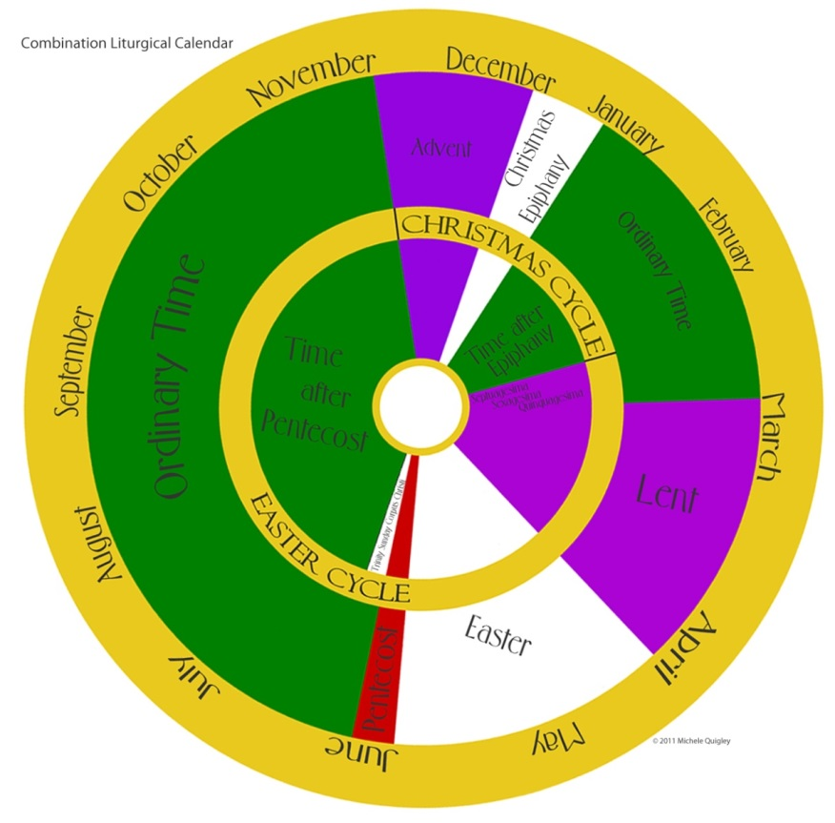

Prayer Table Cloth Colours
Green for Ordinary Time from September to the first Sunday of Advent, 2nd December.
Purple during the 4 weeks of Advent, beginning 2nd December until after Christmas break.
White on return after Christmas until 14th January.
Green during Ordinary Time from 15th January to 5th March.
Purple for Lent, beginning on Ash Wednesday, 6th March until 18th April, Holy Thursday.
White for 50 days of the Easter season, beginning on 21st April to Pentecost on the 9th June.
Green during Ordinary Time, beginning on 10th June after Pentecost Sunday through until Advent.

The normal liturgical colour for Ordinary Time—for those days when there is no special feast—is green. Green vestments and altar cloths have traditionally been associated with the time after Pentecost, the period in which the Church founded by the risen Christ and enlivened by the Holy Spirit began to grow and to spread the Gospel to all nations. Green symbolizes the renewal of vegetation and generally of living things and the promise of new life.
Purple has traditionally been the primary colour of Advent, symbolizing repentance and fasting. Purple is also the colour of royalty and the sovereignty of Christ, demonstrating anticipation of and reception of the coming King celebrated during Advent.
Purple is used during Lent for two reasons: firstly because it is associated with mourning and so anticipates the pain and suffering of the crucifixion, and secondly because purple is the colour associated with royalty, and celebrates Christ's resurrection and sovereignty.

