St Joseph’s Catholic Primary School & Nursery
STARTING SCHOOL
Our family at St Joseph‘s Learns, Loves & Grows with God at the Centre.

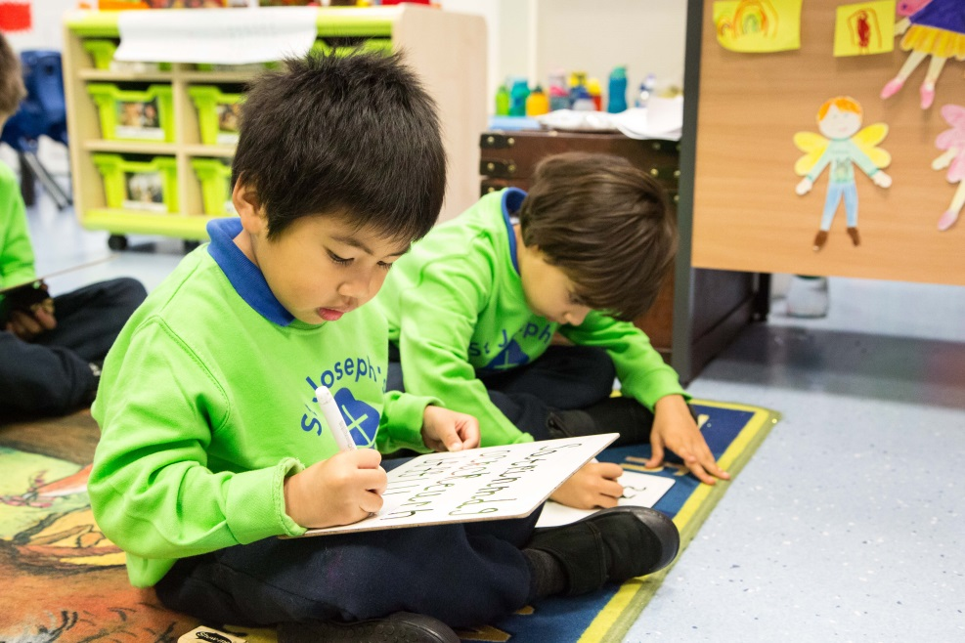
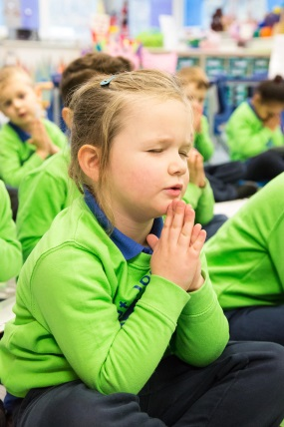
Our School Prayer
This is our school, let peace be found here.
Let the rooms be full of
happiness.
Let love abide here,
love for one another,
love for God.
Let us remember that as many hands build a house
so many hearts make a school.

Amen

Starting school is a big step for your child. We hope to make it a happy and positive experience.
At St Joseph’s we aim to provide a happy and secure environment with planned play and learning experiences. Your child will have the opportunity to explore, develop and extend their skills and knowledge. They will be encouraged to develop a sense of independence and self-confidence.
Our family at St Joseph’s Learns, Loves & Grows with God at the Centre
Starting School
You are also welcome to make an appointment to discuss your child’s individual needs with the class teacher during the first weeks of term.
Settling In
The School Day - 8.55am – 3.15pm
Parents are requested not to allow children to be on the premises before 8.40am. You may bring your child to the classroom from 8.40am.
School gates open at 3:00pm please wait at the designated pick-up point in the infant playground to meet your child at the classroom door at 3.15pm.
If you are delayed DON’T PANIC and please contact the school as soon as possible. Your child will be taken to wait by the school office.
It is VERY IMPORTANT to inform school by letter or email message if you have arranged for someone else to collect your child. It is a good idea to also let your child know who they should expect to collect them at the end of the day.
School office email is office@st-josephs.islington.sch.uk and telephone number 0207 272 1270
If you have asked someone else to collect your child from school, except in an extreme emergency, always leave a WRITTEN message with the class teacher. If an adult unknown to staff arrives to collect your child, they will be asked to wait at the office until you have been contacted and given your permission)
If your child will be late in school due to a medical or other appointment, please email the school office or you can also leave a telephone message on option 1. In this way your message will get to the right person.
Visitors to the School
Any parents or other people visiting the school during the school day must report to the school office and sign in for safeguarding purposes. There are staff/adult toilets within the school and parents/carers are requested to use these even if accompanied by a younger sibling and not to use the children’s toilets.
Messages to children
If you wish to get a message to your child about late arrangements, please feel free to contact the office ideally before 12:00pm after that we cannot guarantee to get the message to your child. Children can, for urgent calls come to the school office to telephone home. Any notification about other people collecting your child must be in writing.
If you wish to get a message to the Enrichment Clubs, After School Club, or Breakfast Club please call the office and leave a message on the After School Line by selecting option 2. Alternatively email office@st-josephs.islington.sch.uk. In this way your message will get to the right person.
School Policies and Information on the website
The school website, http://www.st-josephs.islington.sch.uk/ can be viewed regularly for news and information as it includes letters emailed to parents and the school calendar for events. The school has a large number of policies and documents which parents are also welcome to read. Class news is updated weekly with photographs. Do visit to see what your child has been up to!
Snack Time
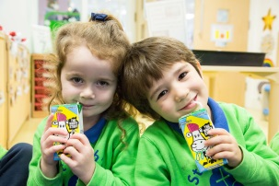
During the morning your child will be given 10 or 15 minutes to have a drink of milk or water and a piece of fruit.
Playtime
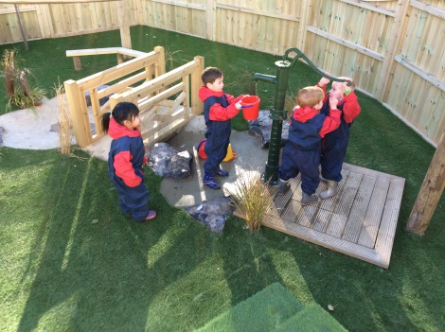
Every day your child will play outside. Remember NAMED coats, hats and gloves for cold weather and sun hats and sunscreen for hot Spring and Summer days. All items – clothing, accessories and water bottles belonging to your child should be labelled /named and it is a good idea to show your child where their name is, so they can recognise their own items.
Lost Property
Any labelled items that are found are returned directly to the children’s classroom. All enquiries regarding lost property should be referred directly to the class teacher or the teaching assistant. Unclaimed items will be donated to the Parents Teachers Association at the end of every term.
LABEL! LABEL! LABEL! Please label ALL of your child’s clothes, bags, lunch boxes, water bottles etc. Show your child where to find the label to help him/her identify their own things. Check labels regularly as they fall off, fade and need replacing.
School Dinners
The school lunch hour is between 11.45am and 1.00pm. All children are entitled to free school meals. Caterlink are the catering contractors who use high quality local food cooked by Sam in the kitchen. Your child can have a school dinner or if they wish can bring a packed lunch. If you are sending a packed lunch please use a lunchbox or cool bag clearly labelled with your child’s name. Please make sure drinks are in leak proof plastic bottles (no glass please!) Healthy lunches include fresh fruit and vegetables and no sweets, chocolates, fizzy drinks or nuts.
Your child will be cared for by the midday supervisors both in the dining area and the playground.
What do I need to buy for school?
We would like all children to take pride in their school and their uniform and make extra effort to wear the correct shoes and jackets as well as the standard uniform. The full uniform list is contained in your pack or you can refer to the list on the website.
Book bags - NO RUCKSACKS FOR NURSERY & RECEPTION
These may be purchased on-line from the School Trends Uniform shop. (After the Autumn half term, your child will begin to bring reading books home please keep these safely in the plastic wallets provided, damaged or lost books are very expensive to replace.) There is a letter regarding lost books in the pack.
Water bottles
These may be purchased from the school office (£1.00 for large, £0.50p for small).

School Uniform Ordering Information.
You order and pay for school uniform online from School Trends:
http://www.schooltrendsonline.com/schools/StJosephsRCPrimaryandNurserySchoolN195NE/
There are no minimum order quantities and your uniform will be delivered directly to your chosen address. Delivery charges for orders under £50 excluding VAT are £4.95. Alternatively you can have your order delivered to the school during term time only free of charge. Please note that the school will not be responsible for orders or any tracking information and you will need to contact School Trends directly for information or queries.
As well as our approved school uniform with our school logo, you can also order plain items such as trousers, skirts and shirts should you wish. A list of uniform items for both boys and girls is attached. Other ordering information including sizes, delivery information and the returns procedure is also available on the website.

Please find attached a description of our school uniform for boys and girls.

We would like all children to take pride in their school and their uniform and so make an extra effort to wear the correct shoes and jackets as well as the standard uniform.

Please ensure that correct school uniform is worn at all times

Thank you for your cooperation.

PLEASE NOTE: Items indicated with * MUST be ordered online from School Trends

EARLY YEARS (Reception and Nursery)
BOYS AND GIRLS UNIFORM | EARLY YEARS EXTRAS
Royal blue collared polo shirt with logo* | Wellington Boots
Lime Green EYFS sweatshirt with logo* | Spare change of school uniform clothes
Navy jogging bottoms | Extra socks and underwear
Navy shorts or leggings can be worn in the summer | Hats, gloves & scarves winter
Black shoes classic school style (Grey socks Only) | Sunscreen & caps with logo*for summer
Black plimsolls (NO trainers)

MAIN SCHOOL UNIFORM (Years 1 to 6)
WINTER UNIFORM BOYS (Autumn and Spring terms) | WINTER UNIFORM GIRLS
Grey blazers with logo* Optional | Grey blazers with logo* Optional
White shirt | White shirt
School tie | School tie
Royal blue jumper or cardigan with logo* | Royal blue jumper or cardigan with logo*
Plain grey long trousers | Plain grey skirt, trousers or pinafore
Grey socks only | Grey socks or grey tights only
Black shoes classic school style (NO trainers) | Black shoes classic school style (NO trainers)

OUTERWEAR ALL YEARS
School coat with logo* Optional
Plain navy, dark grey or black coat (No other coats permitted including denim, fur, leather or brand logos)
Winter Fleece Blue Hats with logo* (No other hats permitted)

SUMMER UNIFORM BOYS (Summer term) | SUMMER UNIFORM GIRLS
Grey blazers with logo* Optional | Grey blazers with logo* Optional
Royal blue collared polo shirt with logo* | Royal blue gingham summer dress
Plain grey long trousers or grey shorts | Royal blue jumper or cardigan with logo*
Grey socks only | White socks only
Black shoes or sandals classic school style  (NO trainers) | Black shoes or sandals classic school style (NO trainers)
School caps with logo* | School caps with logo*

MAIN SCHOOL PE (Years 1 to 6)
Lime Green T shirt with logo*
Navy jogging bottoms or navy shorts no slogans
Trainers

Jewellery - No jewellery except a plain watch and plain gold/silver stud earrings are permitted. No coloured accessories or jewellery are allowed.
Hair - Hair should be tied back with plain navy, royal blue, white or black hair bands/ribbons used. No large flowers or bows. Beads in hair should be in school colours and hair dye or coloured hair extensions are not permitted.
Nail varnish - is not permitted in school.

Welfare at School
Health and safety
If your child is ill you must notify school office of their absence leaving a telephone message (option 1) or email the School Office before 8:00am.
Please do not send your child to school if they have recently been sick or had diarrhoea. In addition to feeling unwell and unhappy, they may spread any infection to the rest of the class. Keep them at home for at least 48 hours after being sick.
If your child suffers from any long term illness such as diabetes, asthma, hay fever please inform the school office and advise of the use of medication, inhalers. Please arrange a meeting with the medical officer to complete a healthcare plan and ensure that all medication is kept up to date.
On occasion your child may become ill at school. PLEASE ENSURE THAT WE HAVE AN UP TO DATE CONTACT NUMBER for you and notify the school of any changes as soon as possible. Please provide 3 separate contacts for your child.
Accidents can and do occur. Injuries are dealt with by staff with first aid training. Where necessary a note may be sent home or you may be contacted to inform you of the injury.
How is he/she doing at school?
You are welcome to discuss your child’s progress with the class teacher. Some days the teacher will be busy with after school activities or meetings but will make arrangements to see you as soon as possible.
During the first year in school your child’s progress will be assessed. We will identify particular areas of strength and areas for development and plan how to help your child continue to develop and achieve their potential.
You will be invited to attend parents’ evenings in the Autumn and Spring terms. You will also receive a written report in the Spring term before Parents Evening.
The most precious commodity you can give your child is your time. The child who gets most from home gets most from school. Please remember that a mutual consideration and respect between parents and school staff is vital, not only before your child starts school, but for as long as your child is at school.
If you have any further questions or concerns, please do not hesitate to contact the school.
Before and After School
Our school day runs from 8.40 am until 3.15 pm. We provide a friendly and safe environment for children at St Joseph’s who need to be cared for out of standard school hours.
Breakfast Club – 8.00 am – 8.40 am. Paid for in advance at £3 concession for siblings
The Breakfast Club, located in the Junior (Key Stage 2) Hall is a calm and comfortable environment helping to ensure the best possible start to the day. Children can enjoy a wide range choice of nutritious hot or cold breakfasts and relax with friends or a book before the busy school day begins.
After School Club – 3.15 pm – 6.00 pm from Nursery to Year 6. Paid for in advance at £10 /£8 concession for siblings
The After School Club is available for all children and is located in the main school building. Nursery and Reception children are cared for in an Early Years setting. There is also a supervised study area equipped with computers for the older children.
How to register: You can register your interest using the Extended School Booking Form and return to this to the School Office.
Enrichment Clubs – Available from Year 1
As part of our commitment to broadening children’s experience at school and nurturing personal development, we offer a full and dynamic programme of clubs during lunch time and after school from 3.15 to 4.15/4.30 pm. By way of example, the following clubs have regularly been offered: art, dance, drama, karate, basketball, rugby, football, gymnastics, ICT coding, garden club, table tennis, film club, cookery club, orchestra, rock club, Italian, science.
Trips and Volunteer Helpers
We believe that educational visits are an integral part of the entitlement of every pupil to an effective and balanced curriculum. Appropriately planned visits are known to enhance learning and improve attainment, and so form a key part of what makes St Joseph’s a supportive and effective learning environment. School trips are an integral part of learning at St Joseph’s and afford many children opportunities which are outside their usual experiences, each class will go on a number of trips each year. We do ask for volunteer helpers on a number of these trips. Volunteer Helpers have an important role to play in the success and safety of the school trip. As part of our school’s risk assessment planning we ask all our volunteers to read, sign and return Volunteer Helper’s form which outlines key responsibilities and expectations in in more detail.
ParentPay
We operate a cashless school and use an online payment and communication system called ParentPay. Through ParentPay we send email and text communication about all school events and ask parents to pay for school trips and contribute to the school Governor's Fund. We will send all new parents instructions on how to open up their account and it is important that you activate your account as we send out all parent letters and texts via this system. Please do not hesitate to contact the school office if you need assistance. If the contribution proves to be too difficult for you financially, please make an appointment to speak to a member of the Senior Leadership Team in confidence. We thank you in advance for your support in using ParentPay as it helps the school enormously.

Tapestry
Learning Journals and special books are used within our early years’ settings as a way to record the special moments of the children, and to keep parents involved, as their children progress and grow. More recently they have been used in conjunction with the Early Years developmental stages to assess more formally how children are progressing.
Traditionally these individual records have been collected in scrapbooks or binders, building up a record of your child’s experiences. All children attending St Joseph’s Nursery and Reception now have this personal diary available on-line to allow parents to be more involved in a sharing partnership with the school.
The advantage of having the Learning Journey on-line is that it is possible to create records of observations instantly and to add notes and images and have them immediately available to any permitted person as part of the complete story of your child's life at our nursery and reception setting. Parents are able to view and comment on these special moments, and are able to contribute their own stories of the child's life outside nursery and reception.
This is what we call Tapestry Online Learning Journals, an online system, which is hosted in the UK on secure servers. You will have secure access (via email address and password) to your child’s Learning Journey and, in addition to viewing our contributions; we encourage you to add to it by uploading photos and comments, or commenting on observations made by us.
In order to set up your individual account prior to your child starting we will ask you to complete and return a form. Once we have set up your account we will write out to you with your individual sign-on and instructions for accessing the account. Please inform the school of any changes to your email address.
Attendance
St Joseph’s prides itself on its attendance record. We believe that regular attendance at school is key to enabling pupils to progress and enjoy learning and ultimately ensures young people have the maximum life chances.
At St Joseph’s we aim to achieve an average of 98% attendance for the year across the whole school. We work hard to support our families and regularly monitor all children’s attendance. In order to encourage good attendance we will:
- continue to award our weekly attendance cup to the class who achieves the highest attendance figure each week;
- issue half-termly attendance certificates at assemblies;
- present an award to pupils with 100% attendance at the end of each year to recognise their outstanding attendance.
As parents we ask you to help by:
- notifying the school promptly if your child is ill or is absent for any other unavoidable reason for example, a visit to secondary school;
- making non-urgent medical appointments outside of school hours;
- booking all holidays outside of term time as St Joseph’s will not authorise term time absences for family holidays. Please remember that there are 190 days of school which leaves 175 days to book family holidays and celebrations;
- making sure children arrive promptly to school. Children need to be seated in class ready for the register at 8.55am and should not be walking through the playground at this time.
At the end of each term the school will write to all parents whose child’s attendance is below 95%. For Persistent Absentees (those whose attendance falls below 90%) we will make an appointment for you to speak to a member of our Senior Leadership Team to discuss your child’s attendance. Please note that Penalty Notices may be issued to parents where children miss 14 sessions within a 10 week period. Hopefully this situation will not arise at St Joseph’s.
We look forward to working with you to improve attendance and improve the learning journey of your child.
St Joseph’s Catholic Primary School Child Protection Policy

Full details of our child protection and safeguarding policy are available on the website but in summary all children have the right to be safe from harm and abuse.

The Governing Body holds responsibility for ensuring that the safety of the children in this school is at all times of paramount importance and recognises the contribution the school makes in safeguarding and protecting children. The Governing Body takes seriously its statutory responsibility to do so and recognises that all staff working with children have a full and active part to play in protecting them from harm.
The Governing Body is responsible for ensuring that any deficiencies or weaknesses in the school’s arrangements for safeguarding and promoting the welfare of children are addressed and remedied without delay. The Governing Body will seek advice from and work in partnership appropriately with Islington Council in fulfilling its safeguarding and child protection responsibilities.
Whilst the Governing Body holds overall responsibility for the child protection and safeguarding functions of the school, the day to day operational responsibility rests with the Headteacher.
The school is committed to providing an environment where children can play, learn, develop and achieve and where they are safeguarded and are enabled to tell or communicate if they are being harmed in some way. We are committed to ensuring that all staff are sensitive to issues of race, culture, gender and diversity but these issues should never be a barrier to sharing and reporting concerns about children.
All staff including teaching and non-teaching staff, temporary and supply staff, clerical and domestic staff, volunteers and staff working on site employed by other services and agencies and those working with children and families in the community have a statutory responsibility to safeguard and promote the welfare of children and must be aware of and fully conversant with this policy. All staff must be given the policy in writing and follow the school’s procedures and guidance at all times.
For the purposes of this document, the term “staff‟ will apply to those listed above.
Because of their day to day contact with children, staff in this school are well placed to observe possible signs of abuse in children.
It is neither the role nor responsibility of those working with children in the school to assess, diagnose or investigate whether a child is at risk of or suffering harm or abuse. It is the responsibility of all staff to be aware of the need to report any concerns about a child to the Designated Member of Staff as a matter of priority or to one of the deputy Designated Members of Staff in her absence.

Our School Building Fund

What is this Fund?

St Joseph’s school is blessed with outstanding facilities in a wonderful location and we are committed to ensuring that our classrooms and playgrounds continue to be as safe and modern as possible to support your children’s learning.

As a Voluntary Aided (VA) school, our grounds and buildings are only partly funded by the Local Education Authority: the government requires all Catholic and other faith schools in England to provide 10% for new developments. We have to rely heavily on parents’ support to raise this and in 2016/17 parents raised a very generous £18,000. Thank you.

What have we achieved so far?

Over the past three years we have created an amazing standalone Library offering an exciting and modern environment for all the children to access a wide range of literature. The School entrance and reception area have been revitalized providing extra space and a pleasant and efficient place for parents and visitors to enter the School.

“The new school entrance represents what the school stands for” - Celesta Year 6
“I really like the new school reception, from the calming colours, to the larger reception desk for parents to speak to staff confidentially, as well as less waiting time when you are in a rush to work” - Parent

Last year we created a state of the art outside learning area for Early Years and now have a show stopping zone for all of our Nursery and reception children. It looks fabulous and provides a wonderful first impression, reflecting the high standards of achievement within the School and offering outstanding provision

“Wow - this is the best play area in the world” - Sadie, Nursery Class

What’s in the pipeline for 2017/18

We are very fortunate to have received a grant to renovate the school Kitchen, which is in need of a complete refurbishment. The school however, will have to provide a 10% contribution to this project and so the target this year is £20,000. With parents support we shall be working hard to raise these funds from September 2017.

How can you help?

By giving the school a voluntary donation of £50 or £100 (if more than 1 child) per family per year the school will be able to reach the target without having to pay from the much needed resources budget for the school.

Donations can be paid in full or instalments via ParentPay. If you are a UK taxpayer you can Gift Aid your donation and boost it by 25p of Gift Aid for every £1 you donate.

The Foundation Stage Curriculum
The Early Years Foundation Stage was revised by the Department for Education in September 2016 and below highlight two areas of learning:
- Personal, Social and Emotional Development.
Known as the Prime Area of Learning
- Communication and Language.
- Physical Development.

- Literacy.
- Mathematics.
Known as the Specific Areas of Learning
- Understanding the World.
- Expressive Arts and Design.

Personal, Social and Emotional Development
We will encourage your child to:
- Learn to share toys and equipment.
- Learn how to value and interact with others.
- Develop independence and confidence.
- Understand the difference between right and wrong.
- Be aware of their own needs/feelings and those of others.
- Learn about the Catholic faith.
- Develop respect for a range of cultures and beliefs.
- Form good relationships with adults and their peers.
- Work as part of a team.
This will be achieved through:
Circle-time activities. Games. Stories. School worship and celebration. Religious education topics. Group and independent work. Free and structured play.
Communication and Language
We will encourage your child to:
- Interact with others.
- Use language in a variety of situations.
- Listen and respond to stories, poems.
- Use their imagination to role play.
- Speak clearly and with confidence in full sentences.
This will be achieved through:
Free and structured play Imaginative role-play. Listening activities. Story time. All scoffolded by ECAT (Every Child a Talker) practitioners.

Physical Development
We will encourage your child to:
- Move with imagination and in safety.
- Be controlled and co-ordinated in their movements.
- Use a range of balancing and climbing equipment
- Be aware of space and of others.
- Understand how to keep healthy.
- Understand what happens to their bodies when they are active.
- Handle tools, objects and materials safely.
This will be achieved through:
Mark making and talking about marks. Activities to improve fine motor control. Outdoor toys. Construction toys. Making models. Using play-dough. Games. Practising basic skills in climbing, balancing, dance and games.
Literacy
We will encourage your child to:
- Learn letters by sound and name.
- Use phonic knowledge to enhance their reading and writing skills.
- Learn to form letters correctly.
- Choose books and handle them correctly.
- Build up a sight vocabulary of words.
This will be achieved through:
Drawing and colouring. Books. Games/jigsaws. Phonics scheme activities. Guided reading/writing. Writing in a wide range of situations.
Mathematics
We will encourage your child to:
- Use, recognise and write number names.
- Count reliably.
- Solve mathematical problems.
- Develop their mathematical language and skills.
This will be achieved through:
Games/Puzzles. Practical activities. Whole class carpet sessions. Number rhymes. Describing and devising simple patterns. Sorting and matching. Using Mathematical language. Sand and water play. Small world/role-play. Using 2D and 3D shapes. Using the computer. Counting, reading, writing and ordering numbers.

Understanding the World
We will encourage your child to:
- Use their senses for variety of activities.
- Find out about living things, objects and events.
- Look at similarities, differences, patterns and change.
- Ask questions about how things work.
- Find out about technology.
- Find out about past and present events.
- Identify features in the natural world.
- Discuss simple environmental issues.
- Know about some features of other cultures.
This will be achieved through:
Investigating materials and objects. Asking questions. Gaining information from a range of sources. Construction toys. Class/group discussions and practical activities. Choosing materials and toys. Sand and water play. Using computers, such as Beebots, the interactive table, technology in the home corner as well as around the school. Growing/caring for plants/ Visits/visitors. Nature walks/activities outside.
Expressive Arts and Design
We will encourage your child to:
- Explore colour, texture, shape, form and space in 2D and 3D.
- Sing simple songs from memory.
- Recognise sounds and patterns in sounds.
- Match movements in music.
- Use their imagination in art, music, design, dance and role-play.
- Respond, express and communicate their ideas, thoughts and feelings in a variety of ways.
This will be achieved through:
Singing. Experimenting and performing with instruments. Imaginative role-play. Drama. Responding and listening to different types and styles of music. Exploring materials e.g. paint, clay, chalk, pastels, pencils, collage and junk modelling. Observing artists work. Appreciating and evaluating their work and that of others. Music and movement sessions. Producing pictures, models etc. linked to topic work.

Ways to help at home
Routine
Try to establish a routine for school days.
- Wake your child in good time to have breakfast and wash and dress in peace.
- Make time after school to listen to them telling you about what they have been doing.
- Your child will be tired when he/she comes home from school. Please ensure that he/she goes to bed early. If he/she does not get enough sleep he/she will not learn efficiently.
- Speaking and Listening: always use speech as a model for your child’s language skills.
Reading
- When parents share books with their children regularly reading becomes a more enjoyable experience and progress in learning to read is enhanced.
- Share books as often as possible.
- Talk about print you see at home or when you are out.
- Let them see you enjoying reading.
- Discuss stories, predicting what might happen next.
- Share poems and rhymes with your child.
- Talk about the cover and pictures in stories. Ask your child to tell their own story using the pictures.
- Encourage your child to finish a sentence by pausing at a suitable place, e.g. Humpty Dumpty sat on a …….
- Playing I-spy, - use letter sounds rather than names.
Writing/Mark making
- Have fun with making marks and discussion about marks
- Chunky pencils/chalk etc. helps to develop motor control.
- Make play dough – develop arm strength
- Use chalk on pavements, outside walls, chalk can be removed by putting water over it.
- If your child is ready to write you could begin by helping them to trace shapes or letters to develop their pencil control. Try writing with a highlighter pen for your child to copy over.
- Encourage your child to hold their pencil correctly – it is better to learn slowly, using the correct technique. If your child alternates the pencil between hands don’t worry as dominance takes time to develop.
- Have lots of paper and writing implements readily available so that they can practise drawing and writing whenever they want to.
- If you choose to teach your child to write his/her name please use a capital for the first letter and lower case thereafter. Once children have formed the habit of writing in capital letters it is very hard to break.
Mathematics
Encourage your child to:
- Learn counting rhymes.
- Weigh and mix ingredients for cooking.
- Count in different situation e.g. stairs, buttons on coats, people at dinner table etc.
- Identify shapes and colours inside and outside your home.
- Describe and sort things into sets e.g. big/small, heavy/light, rough/smooth.
- Recognise numbers up to 10, then 20.
- Gardening (let them help you care for a small section of plants).

