From Lent to Easter - Year B  Linking School, Parish and Home |  | 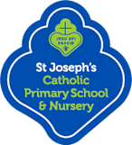 | 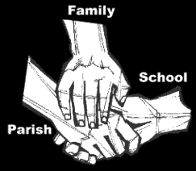
Religious Education
Key Idea: From Lent to Easter
This topic is intended for the Spring Term or 2018 and as the conclusion to the previous resource. Having been presented with the story of the Exodus and within it, the Passover, pupils are now taught how it acts as foundation for our own Eucharist. As this is the Year of Mark, pupils will focus on Mark’s account of the Last Supper of Jesus.
This resource also teaches the Examen, the Jesuit prayer form, as part of preparation during Lent.
Attitudes and Spiritual Dispositions
Spiritual Outcomes: It is hoped that pupils will develop:  It is hoped that pupils will develop:  - A sense of the sacred presence of God in life  - An appreciation of/for Jewish ancestry | - An openness to learning from other faiths  - A willingness to pray
Activities to try at home
You are the first educator of your child in faith. Your child’s learning in religious education will be much greater if you and the school are engaged in talking about the same ideas and beliefs.
- Make mealtimes a time of celebration and ritual. Be more conscious of sitting at the table, of saying grace and of talking together about your shared, family story.
- Ask your children to talk to you about the class Drawer of Life!

An idea for prayer at home
Prayer Activity
Pray at bedtime with your children:

God of our day. Thank you for all those who have brought us your love, kindness and care. May tomorrow be filled with a sense of your presence and may we be for others the God you are for us!
Amen.

