Beginning with the Church  Linking School, Parish and Home |  | 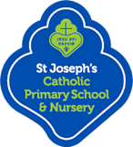 | 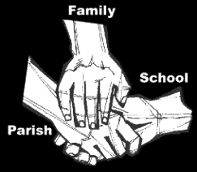
Religious Education
Key Idea: Beginning with the Church
This topic is intended for the first of the academic year 2017/2018. As we welcome new and returning members to our schools community, we learn about how the Church formal welcomes nee members in study of the sacraments of Initiation. This topic is the last in our study of the Year of Matthew.

Attitudes and Spiritual Dispositions
Spiritual Outcomes: It is hoped that pupils will develop:  - A sense of the importance of the sacramental life of the Church  - A commitment to celebrating their faith | - An openness to the presence of God in the Sacraments  - Reflectiveness in prayer
Activities to try at home
You are the first educator of your child in faith. Your child’s learning in religious education will be much greater if you and the school are engaged in talking about the same ideas and beliefs. Help your child by trying this activity while this topic is being taught:
- Welcoming people into our homes, workplaces and communities is part of life. Talk with your pupils about how you welcome new friends and family and why. Making people welcome is the first moment when we say to them you matter to us – you are important and valuable to us…and to God.

An idea for prayer at home
Prayer Activity
Loving God, as we gather as a family today/tonight, may we remember your great love for us. You call us your daughters and sons, making us all members of one family. This day and tomorrow might we remember to welcome and show our love and appreciation for those around us: old friend and new. Make us people who welcome as you did – inviting others to be part of your family, your home.
Amen.

