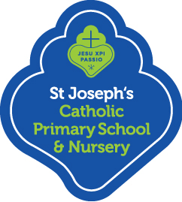
Photographs, Videos and St Joseph’s Website

We take photographs and videos of the children at work and play (including during assemblies and shows). These are used as teaching tools, assessment evidence as well as displayed in our school classrooms and on our website.
Please sign below to give permission or otherwise for photographs and videos to be taken of your child and displayed within our school and on our website and marketing material.
Child’s name:

I give permission for photographs to be taken of my child. YES NO

I give permission for videos to be taken of my child. YES NO

Parents/Carers signature: Date:
We must ensure we protect and safeguard all children and staff, including those who do not want to have their images stored online.

- Once posted and shared online any image or video can be copied and will stay online forever.
- Some children are at risk and MUST NOT have their image put online. Not all members of the community will know who they are.
- Some people do not want their images online for personal or religious reasons.
- Some children and staff may have a complex family background which means that sharing their image online can have unforeseen consequences.

Please be aware that parents are not permitted to take photographs or to make a video recording for their own personal use during any school events.

