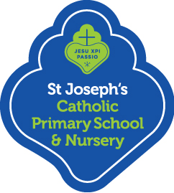

St Joseph’s Catholic Primary School & Nursery

FORMS
Our family at St Joseph‘s Learns, Loves & Grows with God at the Centre.

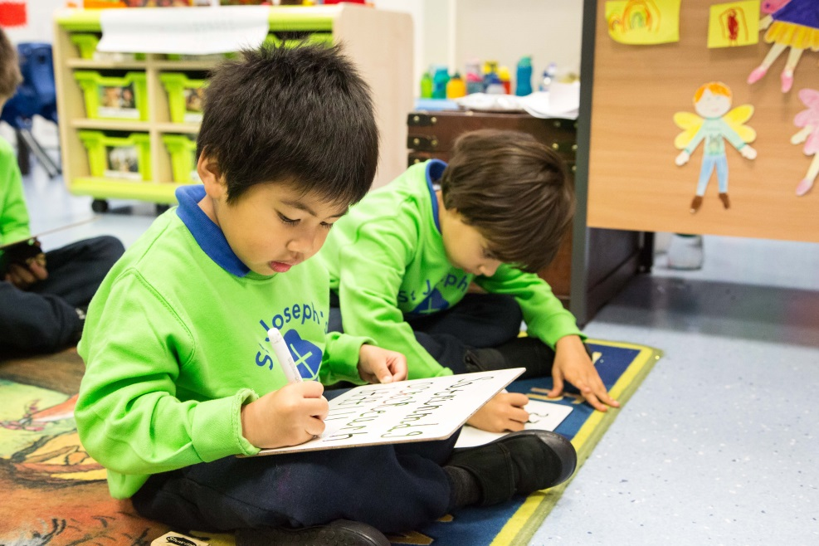

Getting to Know Your Child

We are delighted to welcome your child to St Joseph’s
In order to know your child better and gain insight to help guide our teaching, we would like to know your child as a person and learner. Please complete the table below so we can ensure your child receives the best settling in experience possible.

We are looking forward to hearing from you and also to begin the year with your child. We also look forward to working with you to support and enrich your child’s academic growth. Thank you for completing this form. It is important to us that your child settles in to their new class as quickly and happily as possible.

What is your child’s name?

Which class will your child be entering?

How does your child express himself/herself best—through art, speaking, writing, music, etc

What are your child’s interests?

Are there any special needs or concerns i.e. Medical, Speech and Language, toileting etc?

St Joseph’s Child Entry Profile

Date:

Name of child

Date of birth
What does your child like to be called? (For your child’s name card)
Family details
(Does your child have any siblings? Are they older or younger?)

What is your child’s first language?
What is your (the main carer’s) first language?
What languages can your child understand?
What languages can your child speak?
What was the name of your child’s previous school & adress
How long did your child spend there? (in terms)

What does your child enjoy doing?

Does your child have any particular worries or concerns?

Is there anything else you would like to tell us about your child?

Are there any other adults other than immediate family living at home i.e. aunts, uncles? (please give details)

Is your child adopted, fostered or privately fostered (looked after by an adult who is not immediate family (i.e grandparent, aunty, uncle etc

Parent/Carer Consent Form Regular Out Of School Activities

Child’s name: _______________________________________ Class: _________

I hereby agree to my child participating in standard activities off the school site, which are within walking distance in the local area, during the school day (8:55am-3:15pm), for example, environmental studies, libraries, shops, parks, swimming, sporting fixtures, and joint activities with other schools.

I understand that:

- My specific permission will be sought for any out-of-school activities beyond those outlined above and which could involve commitment to extended journeys or times, expense or adventure activities.

- All reasonable care will be taken of my child in respect of the activity/visit.

- My child will be under an obligation to obey all directions given and observe all rules and regulations governing the visit/activity and will be subject to all normal school discipline procedures during the visit/activity.

- I will inform the school in writing of any medical condition or physical disabilities now, and/or as and when they arise and also advise the school if I do not wish my child to participate in local visits.

- I consent in the event of an accident or illness to my child, to any necessary medical treatment being given. I authorise a member of staff to sign the necessary consent forms for such treatment on my behalf.

- I will not hold the head teacher or any adult member of the party responsible for any loss during such visit of any personal effects, money or injury incurred by my child where reasonable steps have been taken to safeguard them.

Full name of Parent/Carer: ____________________________________________________

Signature of Parent/Carer: _____________________________Date:_____________________

Child Collection /Pick Up Authorisation

Parents / carers will be given permission to collect based on information added below. Please also add anyone else who might be likely to pick up on your behalf. In the case of one of these people collecting your child we will require that they display suitable identification before they will be allowed to take your child.

Name of Child:……………………………………………….. Class……………………

Name

Contact telephone No.

Relationship to Child

Name

Contact telephone No.

Relationship to Child

Name

Contact telephone No.

Relationship to Child

Name

Contact telephone No.

Relationship to Child

Parent Signature: ……………………………………. Date……………………

Parent Name: …………………………………………………………………………..
Photographs, Videos and St Joseph’s Website

We take photographs and videos of the children at work and play (including during assemblies and shows). These are used as teaching tools, assessment evidence as well as displayed in our school classrooms and on our website, twitter feed, tapestry and marketing material.
Please sign below to give permission or otherwise for photographs and videos to be taken of your child and displayed within our school and on our website, twitter feed and tapestry and marketing material.
Child’s name:
I give permission for photographs to be taken of my child. YES NO

I give permission for videos to be taken of my child. YES NO

Parents/Carers signature: Date:
We must ensure we protect and safeguard all children and staff, including those who do not want to have their images stored online.

- Once posted and shared online any image or video can be copied and will stay online forever.
- Some children are at risk and MUST NOT have their image put online. Not all members of the community will know who they are.
- Some people do not want their images online for personal or religious reasons.
- Some children and staff may have a complex family background which means that sharing their image online can have unforeseen consequences.

Please be aware that parents are not permitted to take photographs or to make a video recording for their own personal use during any school events.

School Library Agreement

Agreement
- I understand that I have the right to borrow a School Library book

- · I understand that I have the responsibility to look after my school library book and return it in the same condition as it was borrowed.

- I agree to inform the Librarian if I have lost or damaged a school book.

- I agree to replace or pay the £5.00 replacement fee for any book that I have damaged or lost.

- · I understand that if I do not agree to the Library Agreement I will not be able to use the school library facility.
Signed: ____________________Child

Signed:_____________________Parent

IMPORTANT NOTICE
Lost, stolen or damaged books must be replaced or a £5.00 fee paid before another book can be taken out the library.

Medical Form

Child’s First Name: Surname: Class:
Known Medical Conditions/Allergies:
Health Care Plan in place? Yes/No Attached
Name of Child’s GP: GP’s telephone no:
Name and address of GP:
EMERGENCY CONTACT no.1:

Relationship to child:

Telephone: Work: Mobile: Home:

EMERGENCY CONTACT no.2:

Relationship to child:
Telephone: Work: Mobile: Home:

---------------------------------------------------------------------------------------
Please complete Permission Form below, for Prescription Medicines. We will not give your child any medicine unless you complete and sign this form. Medicine can only be given if there is a Health Care Plan in place or it is necessary to administer 4 times per day.
Medicines must be in the original container as dispensed by the Pharmacy.

Date:

Name of Medicine: Expiry date:
Dose to be administered: When to be given:
Any other instructions:
This arrangement will cease on ___________ (end of course of medicine or until instructed by parent/carer).
I confirm that the above information is correct and accurate at time of writing. I give consent to the staff of St.Joseph’s Catholic Primary School to administer the above medicine in accordance with the School policy.

Parent/Carer name: _________________ Parent/Carer signature: _________________

For School use only:
Medicine checked to prescription : Yes Health Care Plan attached

Staff name: _______________Staff signature _______________ Date: ______________

Headteacher’s name: _________________Headteacher’s signature: ___________________
Ethnic Monitoring Form

The information you provide will be used to compile statistics on the school population of Islington in order to get a true picture of the different ethnic backgrounds within the borough. If you do not want us to record this information about your child, please tick the box at the end of the form. Please return the completed form to the school office.

Child’s name __________________________________________________________

If this information relates to more than one child you have at this school, please write their name(s) and their class(es) below:

_________________________________________________________ _________

_________________________________________________________ _________

WHAT IS YOUR HOME LANGUAGE…………………………………………………………………………

WHAT IS YOUR FIRST LANGUAGE……………………………………………………………………………

WHAT IS YOUR CHILDS COUNTRY OF BIRTH …………………………………………………………

WHAT IS YOUR CHILDS NATIONALITY …………………………………………………………………..

PLEASE TICK ONLY ONE OF THE FOLLOWING BOXES

 | √ | Ethnicity |  | √ | Ethnicity
British White |  | English (WENG) | Black Other |  | Black European (BEUR)
 |  | Scottish (WSCO) |  |  | Black North American (BNAM)
 |  | Welsh (WWEL) |  |  | Black Other (BOTB)
 |  | Other White British (WOWB) |  |  | Any Other Black Background (BOTH)
Other White |  | Albanian (WALB) | Chinese |  | Chinese (CHNE)
 |  | Bosnian-Herzogovenian (WBOS) |  |  | Hong Kong Chinese (CHKC)
 |  | Croatian (WCRO) |  |  | Malaysian Chinese (CMAL)
 |  | Greek (WGRK) |  |  | Singaporean Chinese (CSNG)
 |  | Greek Cypriot (WGRC) |  |  | Taiwanese (CTWN)
 |  | Greek / Greek Cypriot (WGRE) |  |  | Other Chinese (COCH)
 |  | Gypsy / Roma (WROM) | Mixed Ethnicity |  | White & Black Caribbean (MWBC)
 |  | Irish (WIRI) |  |  | White & Black African (MWBA)
 |  | Kosovan (WKOS) |  |  | White & Asian (MWAS)
 |  | Italian (WITA) |  |  | Any Other Mixed Background (MOTH)
 |  | Portuguese (WPOR) |  |  | White & Pakistani (MWAP)
 |  | Serbian/Yugoslavian (WSER) |  |  | White & Indian (MWAI)
 |  | Traveller of Irish heritage (WIRT) |  |  | White & any other asian background (MWAO)
 |  | White Eastern European (WEEU) |  |  | White & Chinese (MWCH)
 |  | White European (WEUR) |  |  | White & any other background (MWOE)
 |  | White Western European (WWEU) |  |  | Asian & Black (MABL)
 |  | Other White (WOTW) |  |  | Asian & Chinese (MACH)
 |  | Any Other White Background (WOTH) |  |  | Asian & any other background (MAOE)
Turkish (3) |  | Turkish (WTUK) |  |  | Black & Chinese (MBCH)
 |  | Turkish Cypriot (WTUC) |  |  | Black & any other background (MBOE)
 |  | Turkish / Turkish Cypriot (WTUR) |  |  | Chinese & any other background (MCOE)
Kurdish |  | Kurdish (OKRD) |  |  | Other mixed (MOTM)
Bangladeshi |  | Bangladeshi (ABAN) | Other Ethnic Group |  | Afghanistani (OAFG)
Other Asian |  | African Asian (AAFR) |  |  | Arab Other (OARA)
 |  | Indian (AIND) |  |  | Egyptian (OEGY)
 |  | Kashmiri Other (AKAO) |  |  | Filipino (OFIL)
 |  | Nepali (ANEP)) |  |  | Iranian (OIRN)
 |  | Pakistani: Unspecified (APKN) |  |  | Iraqi (OIRQ)
 |  | Pakistani: Kashmiri (AKPA) |  |  | Japanese (OJPN)
 |  | Pakistani: Mirpuri (AMPK) |  |  | Korean (OKOR)
 |  | Pakistani: Other (AOPK) |  |  | Libyan (OLIB)
 |  | Sinhalese (ASNL) |  |  | Latin/South/Central America (OLAM)
 |  | Sri Lankan Tamil (ASLT) |  |  | Lebanese (OLEB)
 |  | Other Asian (AOTA) |  |  | Malay (OMAL)
 |  | Any Other Asian Background (AOTH) |  |  | Morrocan (OMRC)
Black Caribbean |  | Black Caribbean (BCRB) |  |  | Polynesian (OPOL)
Black African Somali |  | Somali (BSOM) |  |  | Thai (OTHA)
Other Black African |  | Angolan (BANN) |  |  | Vietnamese (OVIE)
 |  | Congolese (BCON) |  |  | Yemini (OYEM)
 |  | Ghanaian (BGHA) |  |  | Other Ethnic Group (OOEG)
 |  | Nigerian (BNGN) |  |  | Any Other Ethnic Group (OOTH)
 |  | Sierra Leonian (BSLN) | Unknown |  | Refused to Say (REFU)
 |  | Sudanese (BSUD) |  |  | Information Not Obtained (NOBT)
 |  | African: Unspecified (BAFR)
 |  | Other Black African (BAOF)

Parent / Carer signature …………………………………………………… Date ……………………………

Extended School

APPLICATION FORM

Please note that this does not guarantee a space on the After School Club as it is dependent on availability and there is a sibling priority given.

Child’s Name _________________________________Class Nursery

Email address ______________________________________________________________
Contact Telephone Number ____________________________________________________
Please tick the following boxes:

I have children who already attend After School Club .

You are going back to work or to study.

If your child has special needs or a disability.

Please tick the box if your joint family income is lower than £24,000 to be eligible for application for a discounted rate.

Please tick boxes relevant to you:

I am interested in applying for an After School Club place at St. Josephs which runs from 3:15pm until 6:00pm at a cost of £10 per session. Sibling concession £8

Please tick required days

MON TUE WED THURS FRI

I am interested in applying for Breakfast Club place at St. Josephs from 8:00am at a cost of £3 per session. No sibling concession

Please tick required days

MON TUE WED THURS FRI

Signed ___________________________________ Date _________________

Charity Gift Aid Declaration – multiple donation

Boost your donation by 25p of Gift Aid for every £1 you donate

Gift Aid is reclaimed by the charity from the tax you pay for the current tax year. Your address is needed to identify you as a current UK taxpayer.

In order to Gift Aid your donation you must tick the box below:

I want to Gift Aid my donation of £______________ and any donations I make in the future or have made in the past 4 years to:

Name of Charity St Joseph’s Catholic Primary School

I am a UK taxpayer and understand that if I pay less Income Tax and/or Capital Gains Tax than the amount of Gift Aid claimed on all my donations in that tax year it is my responsibility to pay any difference.

My Details

Title ____________________ First name or initial(s) ___________________________

Surname _______________________________________________________________

Full Home address _______________________________________________________

_______________________________________________________________________

_______________________________________________________________________

Postcode __________________________ Date ________________________________

Please notify the charity if you:
- want to cancel this declaration
- change your name or home address
- no longer pay sufficient tax on your income and/or capital gains

If you pay Income Tax at the higher or additional rate and want to receive the additional tax relief due to you, you must include all your Gift Aid donations on your Self-Assessment tax return or ask HM Revenue and Customs to adjust your tax code

Free School Meals to all Nursery and Primary children
Islington is one of the few councils in England to offer free school meals for all nursery and primary pupils in its schools.

Research has shown that healthy free school meals improve children’s learning and productivity, whilst saving you money in tough times. The number of children benefiting from free school meals in Islington has increased significantly over recent years and we have been getting great reports about the quality of our meals. Our free school meals meet strict nutritional standards, and the quality and sustainability of our meals helped Islington to be awarded 2012 top ‘Good Food Borough’ by London Food Link.

Registering could raise money for your child’s school

It’s important to sign up for free school meals as registering could also raise an extra £1,320 for your child’s school from central government, to fund valuable support like extra tuition, learning assistants or after school clubs. Even if you don’t want your child to receive a free meal, we would encourage you to register for free school meals so that their school receives as much funding as possible!

To register for your child to receive free school meals, please complete the simple on-line form.

https://www.islington.gov.uk/children-and-families/benefits-and-financial-support/free-school-meals-and-uniform-grant

Parents who do not complete/renew their application may not benefit from the free meal and may be required to pay for their child’s meal. It is therefore very important that you complete the form and return to your child’s school as soon as possible.

It would be beneficial to the school if children who choose not to take up the opportunity of a Free Meal, and would like to remain on packed lunches, can still complete the form.

How the information in this form will be used

The information you provide in this form will be used by the council to claim extra grant money from the government to pay for free school meals, sports funding and other things, like music and after school activities for Islington children. This information helps to decide how much money your child’s school will receive each year too.
The information will also be used by your school to assess the charges for after school clubs and school trips.

It is really important that you complete all the information asked for in this form to help make sure Islington schools are as well funded as possible.

HOME SCHOOL AGREEMENT
Schools Commitment

We at St Joseph’s, acknowledge our responsibility to support parents in nurturing their children towards human wholeness within a Catholic community and therefore undertake to:

- Provide a safe welcoming, friendly environment for children and parents.
- Expect all staff and children to treat each other with care and respect.
- Demonstrate our Faith and our school’s foundation in the teachings of Jesus Christ by what we teach and the way we live and worship in our school.
- Challenge and encourage all children to strive for the highest standard of personal, social and intellectual development and to aim for excellence in all that they do.
- Provide a well-planned and balanced curriculum.
- Provide parents with information about their child’s progress through regular meetings with teachers and an annual report.
- Inform parents of any concerns regarding their child’s behaviour, work or health.

HOME SCHOOL AGREEMENT

Parents Commitment

I/We acknowledge that as parents /guardians, we are the primary educators of our children, and have an irreplaceable role to play in supporting our children at school.

I/We undertake to:

- Support the school’s aims and policies and the Christian values of the school community.
- Expect all parents/guardians to treat each other, children and members of staff with care and respect.
- Ensure that our child comes to school on time each day and that the school is informed of any absence.
- Ensure that our child brings to school everything needed for the day, and wears the correct uniform.
- Encourage our child to work hard and behave well, showing respect to teachers, their fellow pupils and the school environment and materials.
- Support our child with their homework and foster an enthusiasm for learning.
- Attend meetings arranged to discuss our child’s progress and the work of the school.

Signed: ________________________________________Child

Signed:_________________________________________ Parent

