Jesus at Prayer - Year B  Linking School, Parish and Home |  | 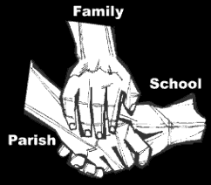
Religious Education
Key Idea: Jesus at Prayer
This topic is intended for the Spring Term of 2018. It presents pupils with the story of the Exodus and within it, the Passover. As a Jew, Jesus would have celebrated Passover with his family; in preparation for Easter this resource teaches pupils about the story that is the foundation for our own Eucharist.
Attitudes and Spiritual Dispositions
Spiritual Outcomes: It is hoped that pupils will develop:  - A sense of the truths contained in Scripture.  - An appreciation of/for our connection to the Jewish people | - Respect for the faith and practices of the Jewish people  - An openness to learning from other faiths
Activities to try at home
You are the first educator of your pupil in faith. Your pupil’s learning in religious education will be much greater if you and the school are engaged in talking about the same ideas and beliefs. This topic takes pupils on a journey back in time to the Exodus. Pupils will be invited to consider the symbolism of the journey the Israelites took and the ritual of Passover which continues to give thanks for the many blessings the people have received.
- Talk to your pupils about what they have: foster a sense of appreciation and thankfulness for the many blessings and privileges they enjoy.
An idea for prayer at home
Prayer Activity
Blessed are You, Lord our God, ruler of the universe, who has kept us alive, sustained us and enabled us to celebrate this joyous occasion.
May we remember all those who live in fear or oppression; help us to work towards their release and freedom.
Amen.

Adapted from the Haggadah, the prayer of the Passover meal.

